Understanding GraphQL Java – Without Spring Getting in the Way
Udemy Course

Index
1 Section 1 – Introduction 3
1 Introduction 3
2 Setting-Up the Environment 3
2 Section 2 – Schema Basics 4
1 GraphQL Types 4
2 First Schema 5
3 Section 3 - Data Fetchers Basics 6
1 Intro 6
2 Creating Our First Data Fetcher 7
4 Section 4 – Exposing over HTTP 9
1 How to make a GraphQL service over HTTP 9
2 Hands on: Creating a GraphQL HTTP service with Jetty 10
5 Section 5 – Connecting to a Database 11
1 Our sample database: the Mondial Database 11
2 Hands On: DataFetcher with Real Data 11
6 Section 6 – Types Deep Dive 15
1 Part 1: Input Types, Enums and Scalars 15
2 Hands On: Add Criteria to Select Countries 16
3 Hands On: Add Criteria to Select Provinces 17
4 Hands On: Adding Custom Scalars 18
5 Part 2: Unions and Interfaces 19
6 Hands On: Implementing places entry point 20
7 Section 7 – Schema Directives and Documentation 24
1 Hands-On: Adding documentation 24
8 Section 8 – Quieres Deep Dive 24
1 Query constructs 24
2 Assignment 5: Exercise your querying skills 26
9 Section 9 – Schema Introspection 28
1 Schema Introspection 28
2 Assignment 6: Querying the GraphQL Schema through introspection 29
10 Section 10 – Schema Evolution 30
1 Managing Schema Changes Smoothly 30
2 Hands-On: Change schema keeping old fields wired 31
11 Section 11 – Schema via Code 32
1 Managing Schema via Code 32
2 Hands-On: Populating pieces of GraphQL schema via POJO introspection 33
3 Assignment 8: Generate the City type via code 36
12 Section 12 – Instrumentation 36
1 Instrumentation 36
2 Hands-On: Logging Query Execution via Instrumentation 37
3 Hands-On: Implementing an Access Control Instrumentation 40
4 Assignment: Implementing DataFetcher Usage Tracing Using Instrumentation 43
13 Section 13 – Execution 44
1 Execution Phases and Asynchronicity 44
2 Hands-On: Making our Data Fetching Asynchronous 45
3 Fetching Data in Batches: Batch Loading 46
4 Hands-On: Using Batch Loading to Optimize the Number of Database Queries 47
5 Assignment: Implement Batch Loading for Provinces 50

Section 1 – Introduction

Introduction
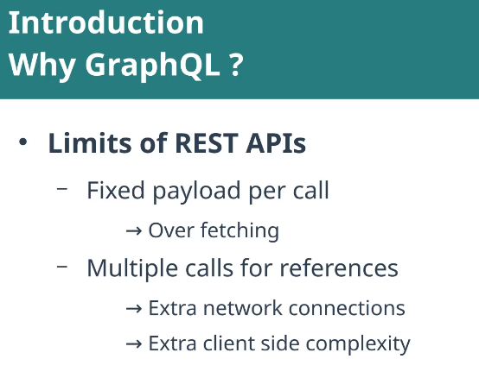
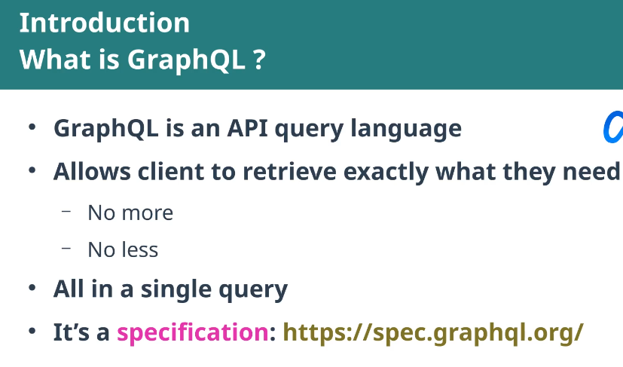

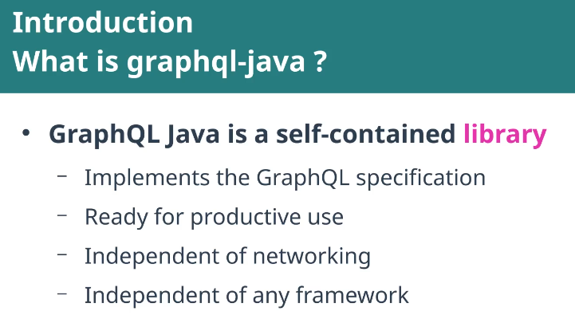

Basic concepts:
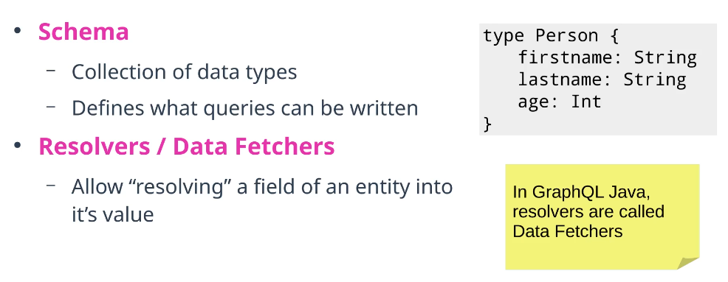

Setting-Up the Environment

Reference:
https://gitlab.com/habegger-learning/graphql-java-course/-/commit/765ad1d5ee4cfb2dac490ec45aec079e0c9edf94

Section 2 – Schema Basics

GraphQL Types
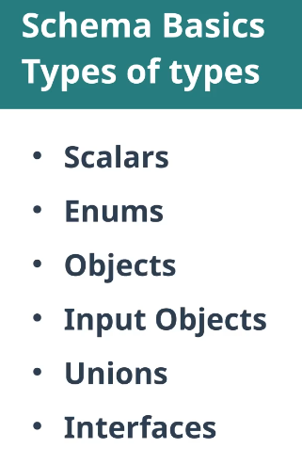
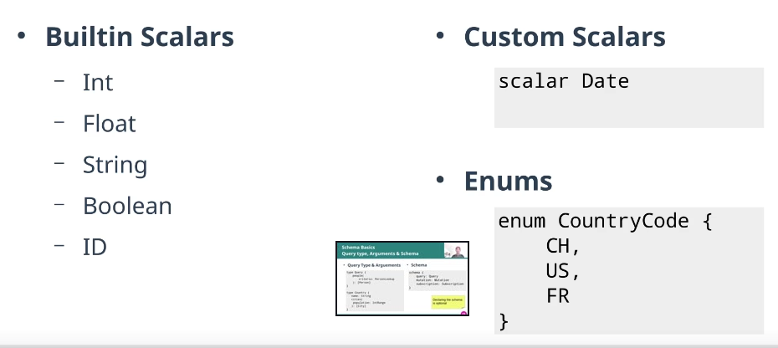

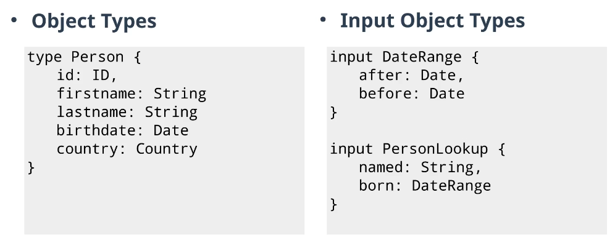

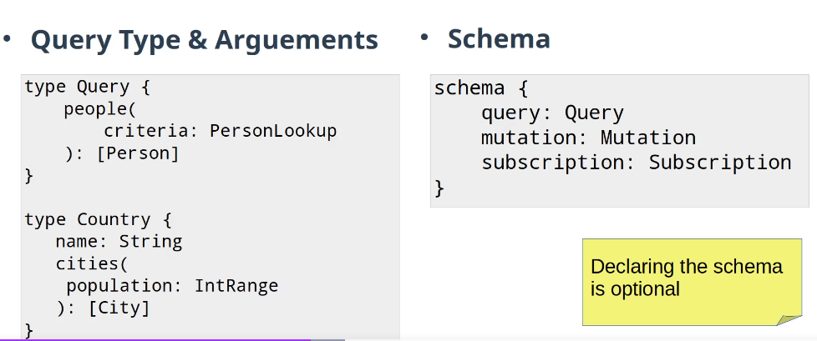

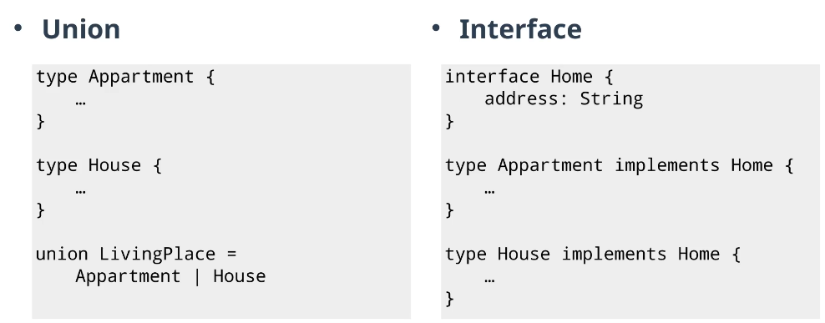

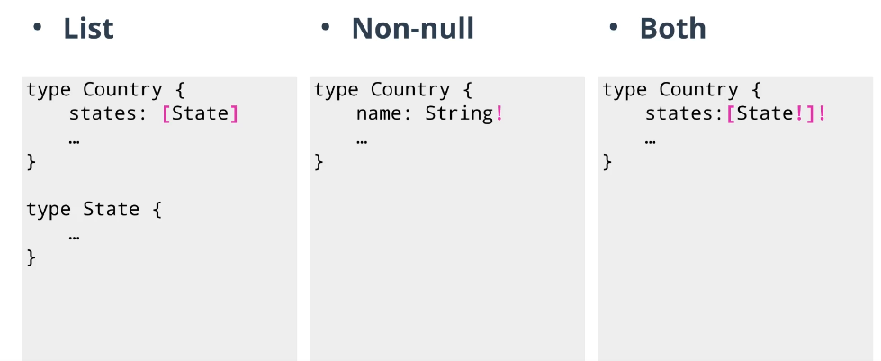

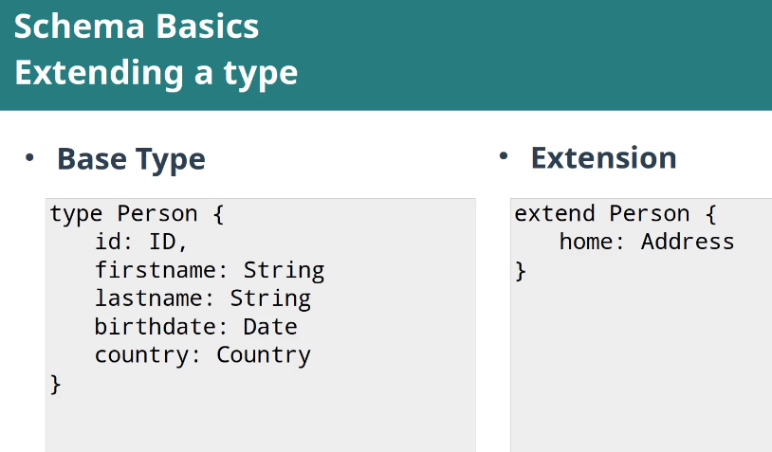

First Schema

Reference:
https://gitlab.com/habegger-learning/graphql-java-course/-/commit/f557fb350fb9f49d64ed59c572dbef2e5fa27675

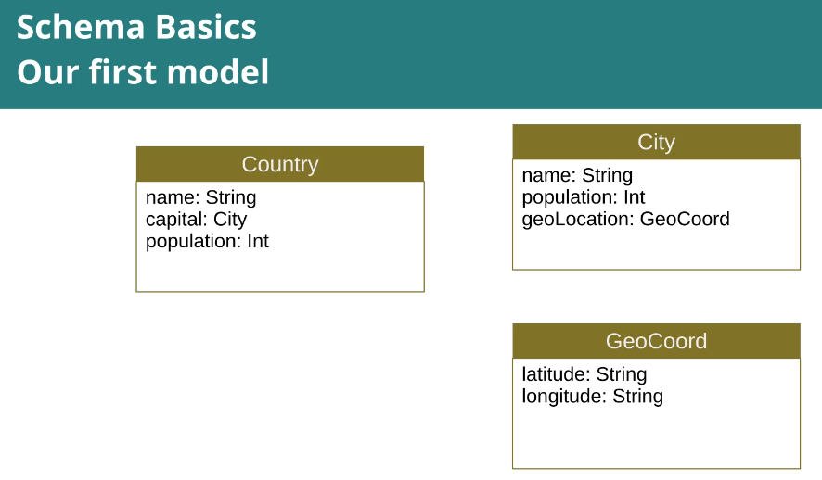
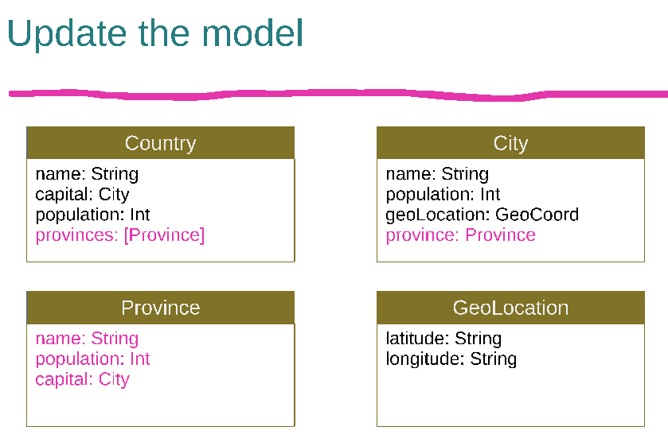

type Query {
countries: [Country]
}
type Country {
name: String
population: Int
area: Int
capital: City
provinces: [Province]
}
type City {
name: String
population: Int
geoLocation: GeoCoord
elevation: Int
province: Province
}
type Province {
name: String
population: Int
capital: City
}
type GeoCoord {
latitude: Float
longitude: Float
}

Section 3 - Data Fetchers Basics

Intro
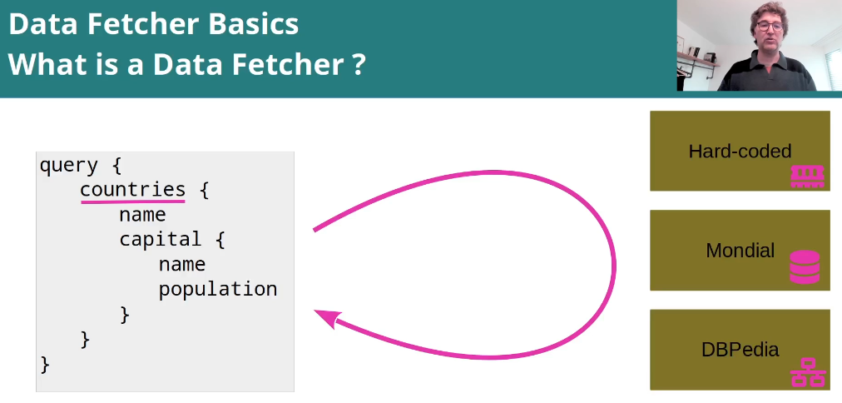

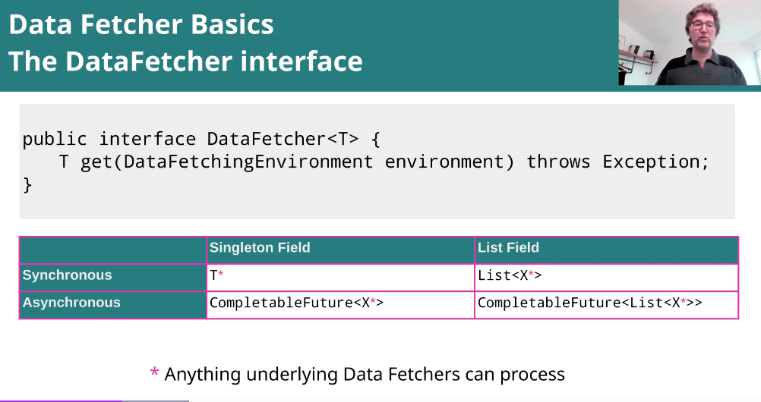

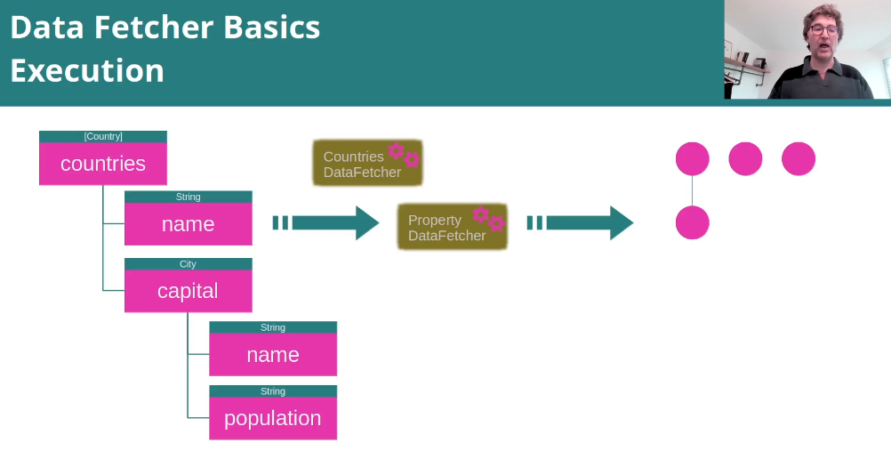

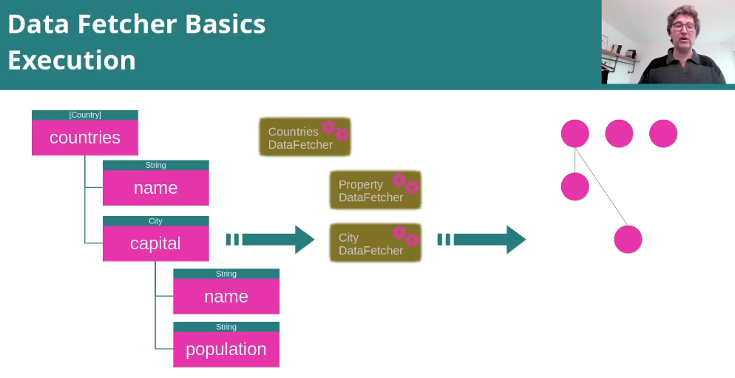

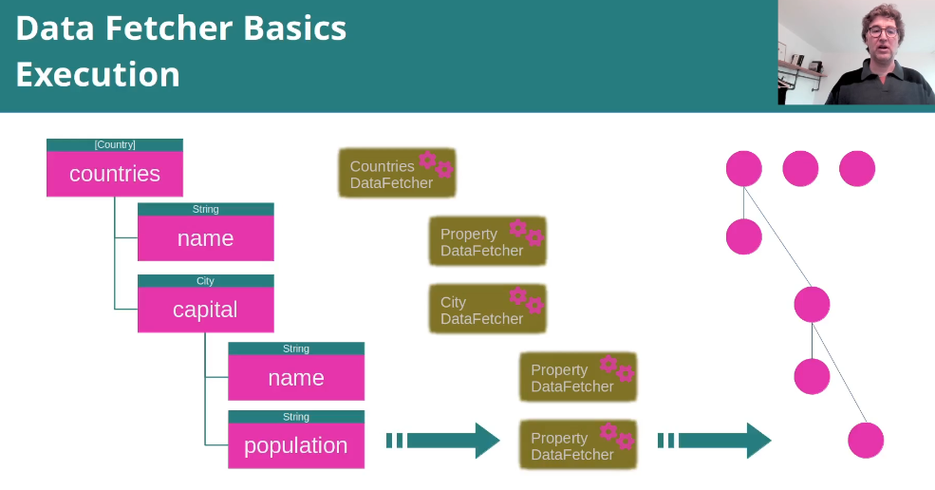

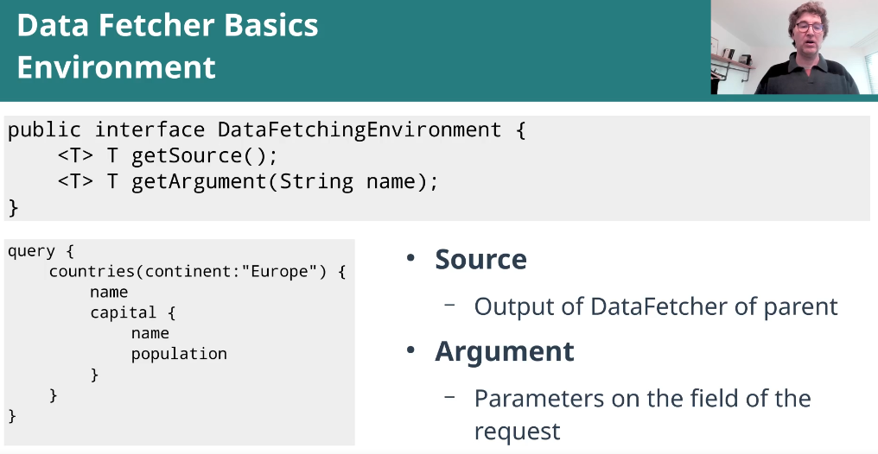

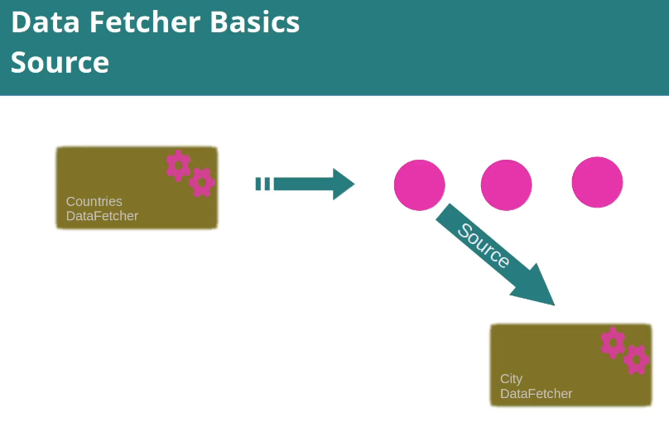

Creating Our First Data Fetcher
We have for now a statid data fetcher
public class StaticCountriesDataFetcher implements DataFetcher<List<Country>> {
private final static List<Country> COUNTRIES = List.of(
new Country("F", "France", 64300821, 547030, "Paris"),
new Country("E", "Spain", 47400798, 504750, "Madrid"),
new Country("CH", "Switzerland", 8670300, 41290, "Bern"),
new Country("PT", "Portugal", 10300000, 92212, "Lisbon")
);
@Override
public List<Country> get(DataFetchingEnvironment environment) {
return COUNTRIES;
}
}

we wire it:

private RuntimeWiring buildRuntimeWiring() {
return RuntimeWiring.newRuntimeWiring()
.type("Query", builder -> builder.dataFetcher("countries", new StaticCountriesDataFetcher()) )
.build();
}

If we try to execute the valid query test again, we get the error:
java.lang.AssertionError:
Expecting empty but was: [NonNullableFieldWasNullError{message='The field at path '/countries[0]/capital/name' was declared as a non null type, but the code involved in retrieving data has wrongly returned a null value.

To solve it, we have to add a data fetcher for that field
private RuntimeWiring buildRuntimeWiring() {
return RuntimeWiring.newRuntimeWiring()
.type("Query", builder -> builder.dataFetcher("countries", new StaticCountriesDataFetcher()))
.type("Country", builder -> builder.dataFetcher("capital", c -> null))
.build();
}

If we debug the test, we can see the data received when executing the query:

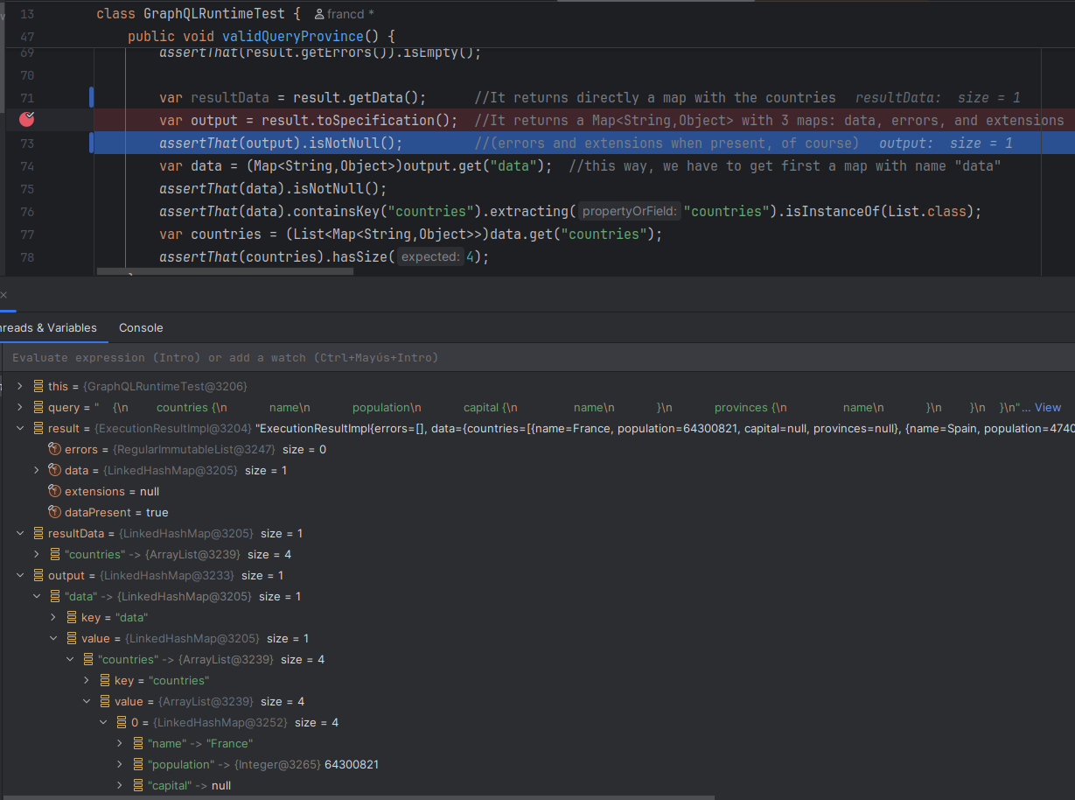
It can be seen that result.getData returns directly a map with the countries, while toSpecification returns a map with 3 maps: data, errors and extensions, as mandatory by the GraphQL specification. (Of course, if there are errors and extensions. In this example that was not the case, the variable result of type ExecutionResultImpl shows neither errors nor extensions).

Now, the city.

We need to access the environment, to get the source of this field. According to the schema, the source of the city is the country, so we have in the data fetcher for this field city:

@Override
public City get(DataFetchingEnvironment environment) {
Country country = environment.getSource();
var capitalName = country.capital();
return CITIES.get(capitalName);
}

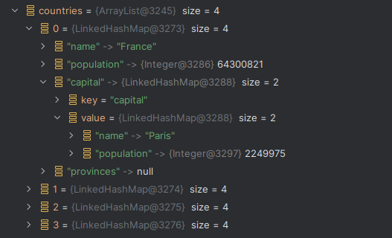
If we debug the test again, now we see we receive also the capital of the country.

(We do the same to get the province of the capital city).

Section 4 – Exposing over HTTP

How to make a GraphQL service over HTTP
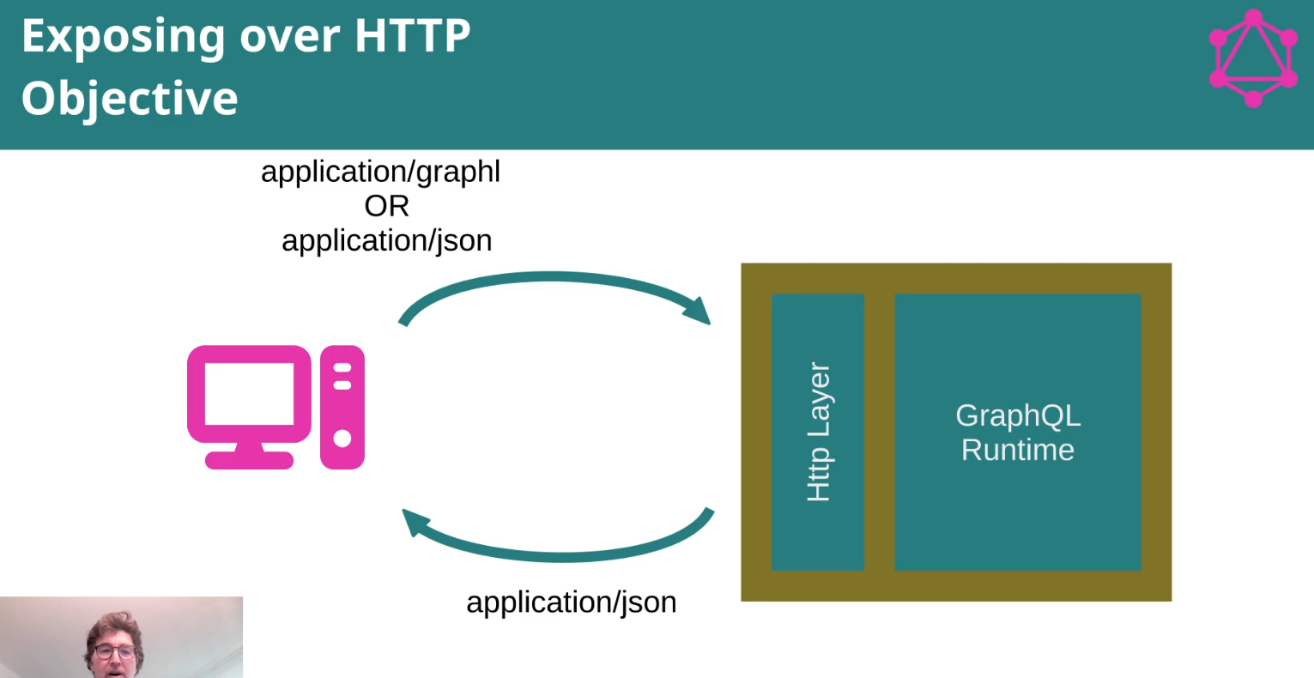

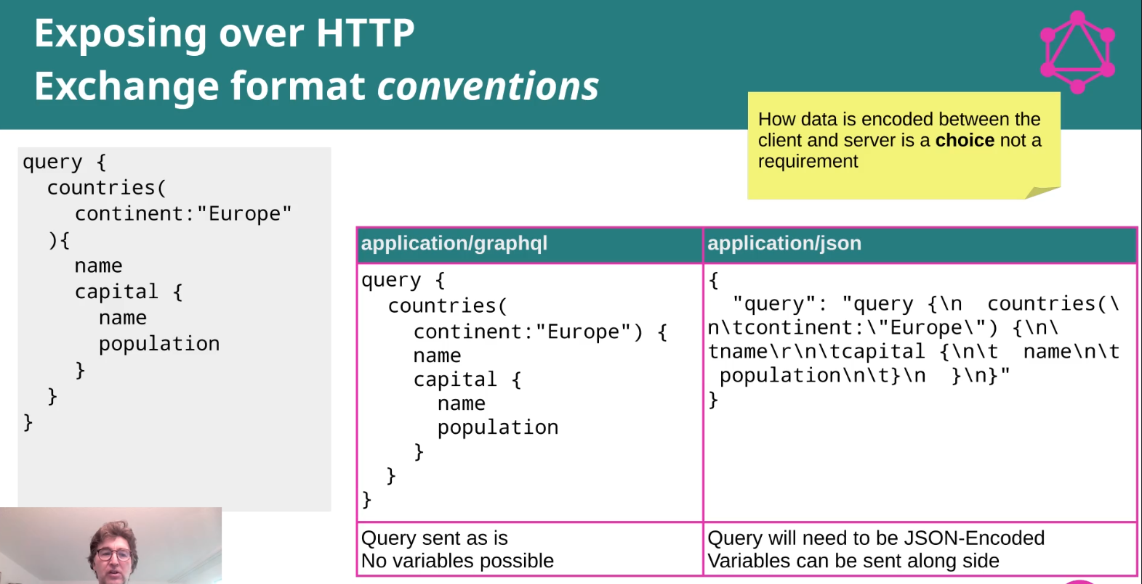

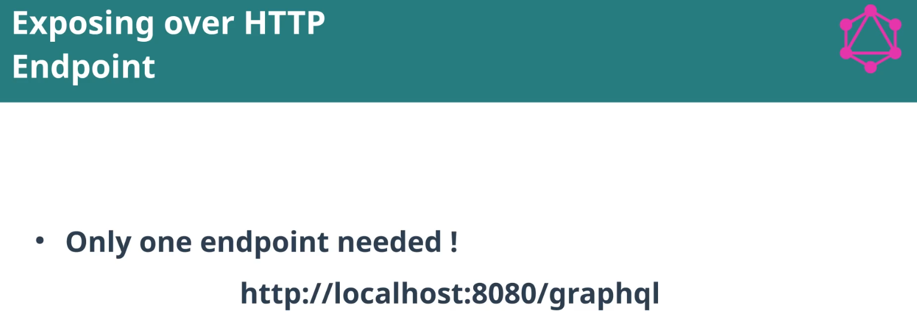

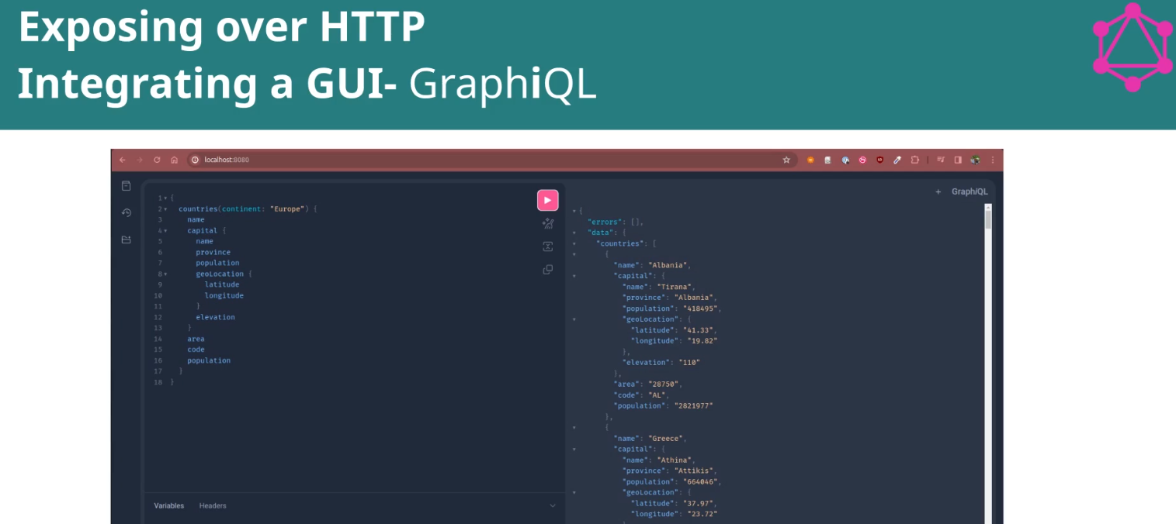

Hands on: Creating a GraphQL HTTP service with Jetty

Add dependencies for Jetty, logging ..
Add in resources a file grahpiql.html with the content from:
https://github.com/graphql/graphiql/tree/main/packages/graphiql ->
https://github.com/graphql/graphiql/tree/main/examples/graphiql-cdn

Correction made to that file (index.html -renamed as graphiql.html):
const fetcher = createGraphiQLFetcher({
url: 'http://localhost:8080/graphql/',
});

If we hit in now the browser http://localhost:8080
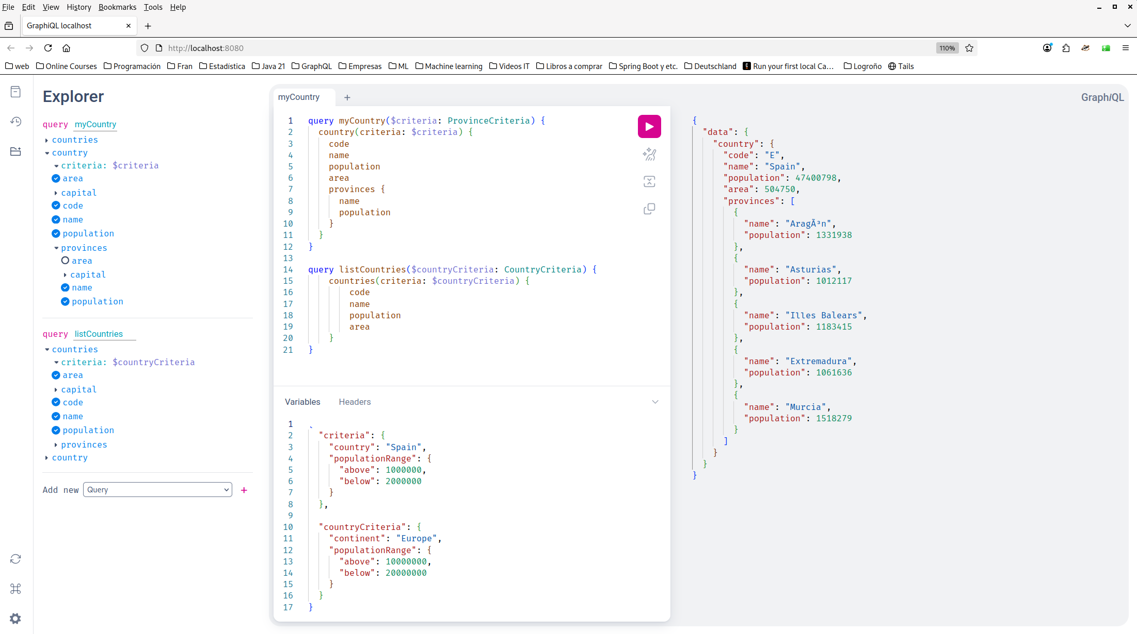

Using postman: (snap run postman)
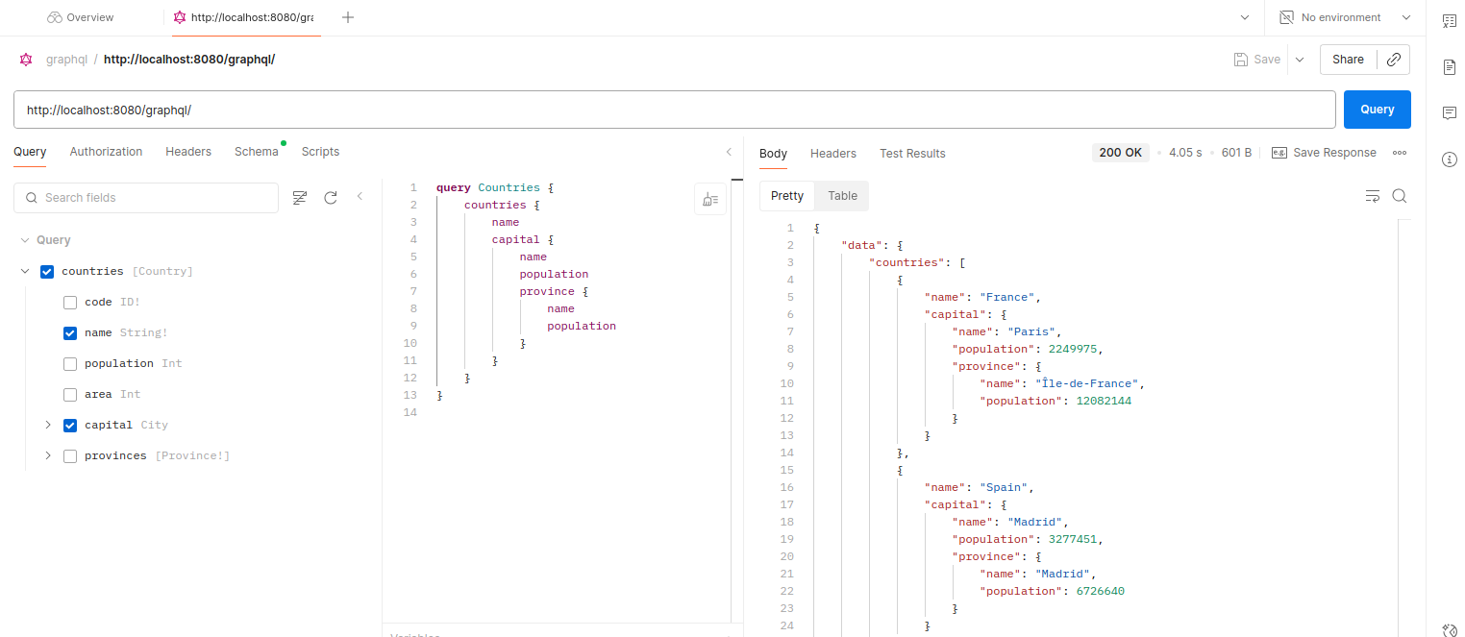
[
A small problem: it seems Postman needs that the schema has .grapql extension so it can read it.
So we rename the schema file to .graphql so it can be used by both Postman and the IntelliJ.
]

Section 5 – Connecting to a Database

Our sample database: the Mondial Database
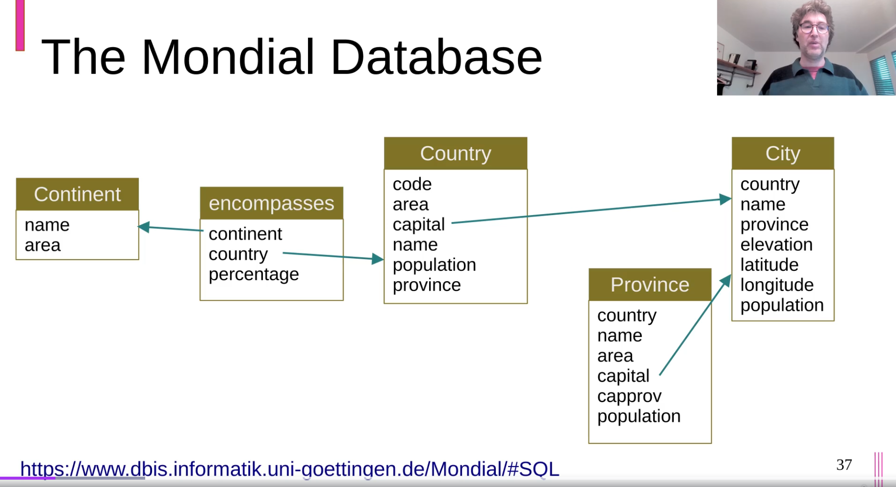

https://www.dbis.informatik.uni-goettingen.de/Mondial/
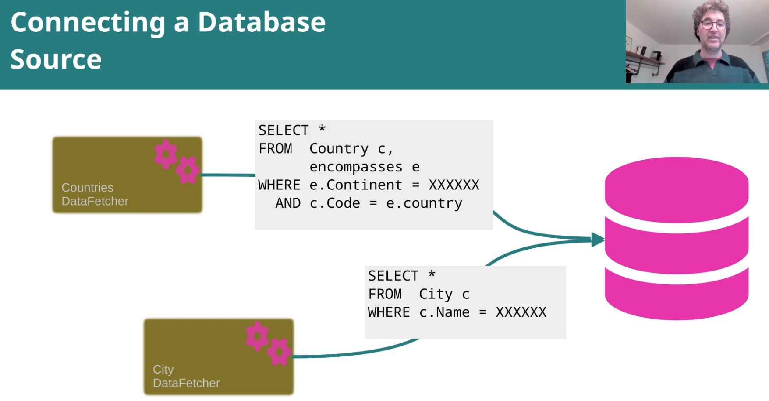

Hands On: DataFetcher with Real Data

Using the docker image:

$ docker run -p 5432:5432 --name mondial bhabegger/mondial (ACTHUNG!! Be careful with the “--“)
$ docker start mondial
Ok, db mondial is running inside docker ← it does not connect … ?
(user/passw: postgres / graphqlcourse)

[ Install plugin Database Navigator ]

- To connect to the db in local server:
(database mondial – user: postgres / postgres789)

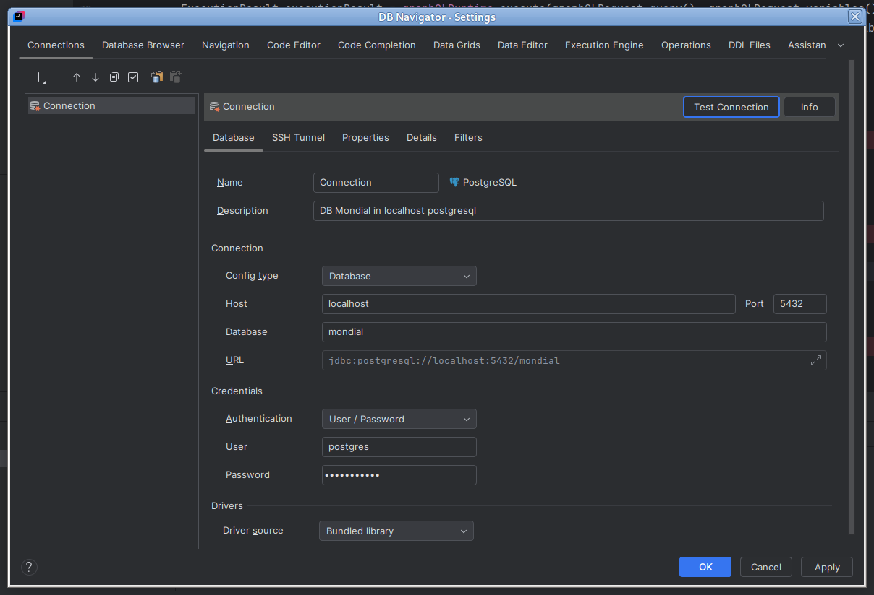

Once the code is ok, we can see this:
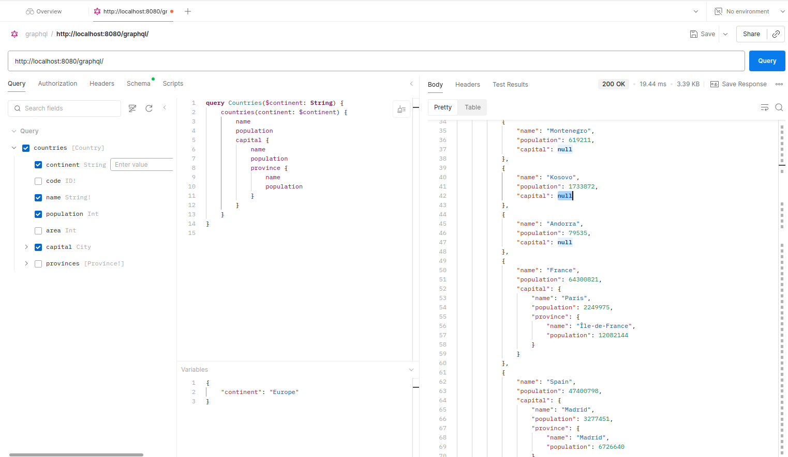
Most of the capitals are null, but not the capital cities of the countries for which we have a static data fetcher for the city.
This is, we are mixing different data fetchers with no problem.

We add the data fetcher for the cities:
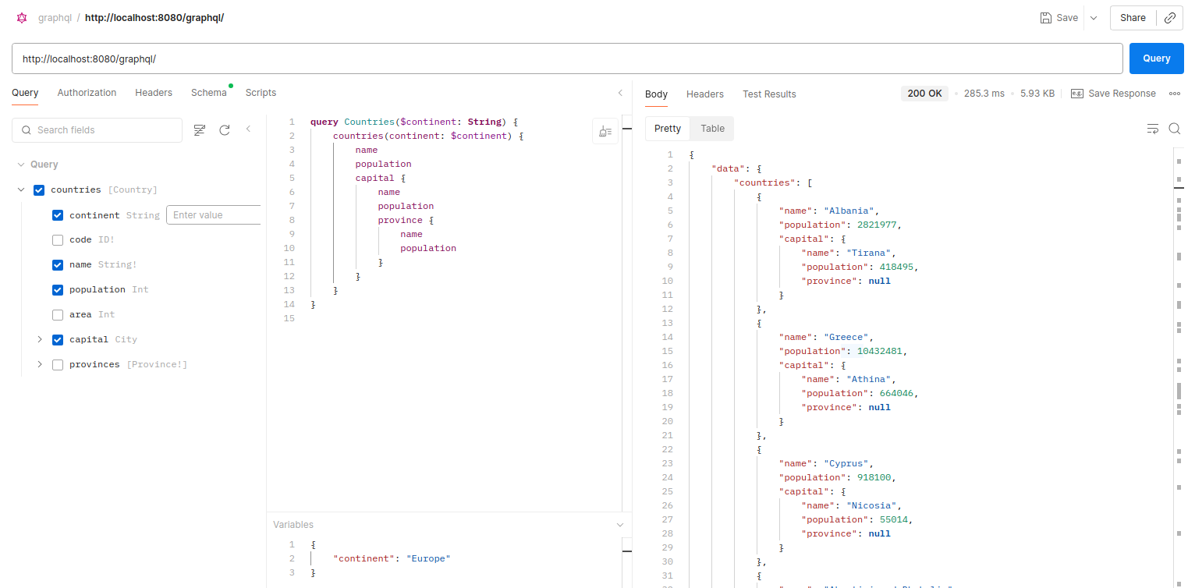
And finally the data fetcher for the province (of the capital) :
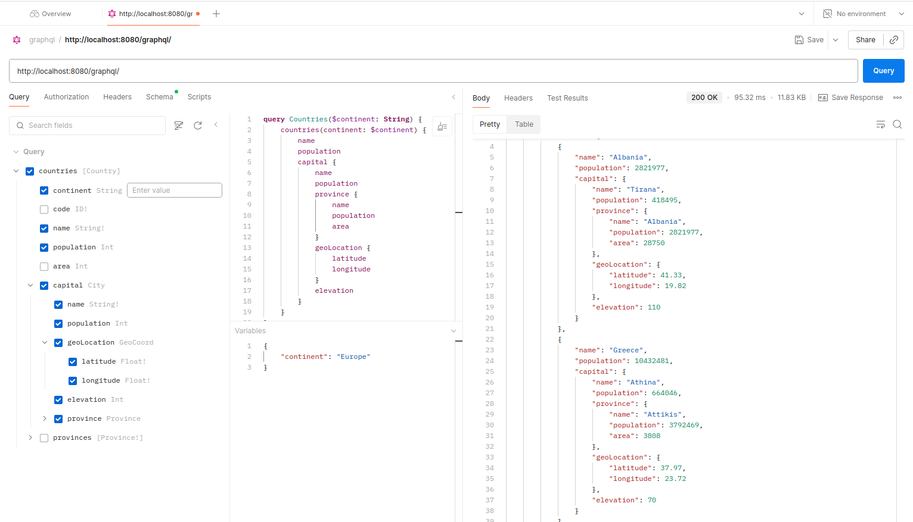

And if we add a data fetcher for the provinces of a country ..
(next page)

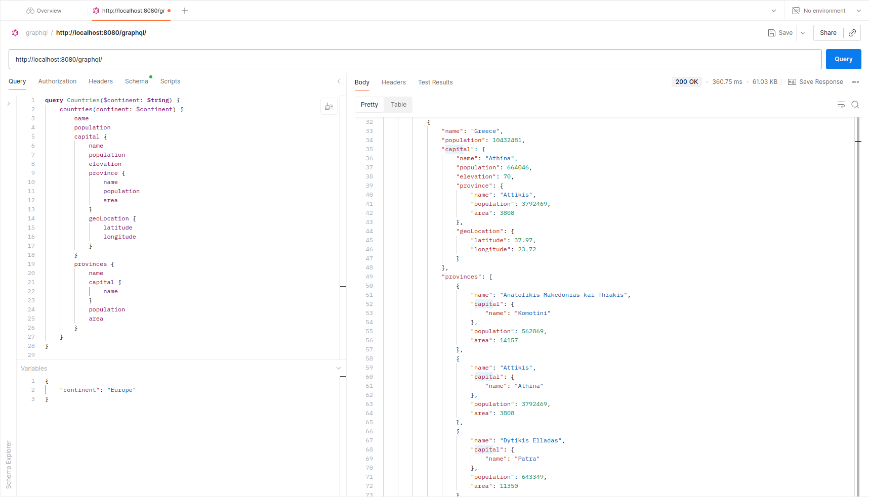

Section 6 – Types Deep Dive

Part 1: Input Types, Enums and Scalars
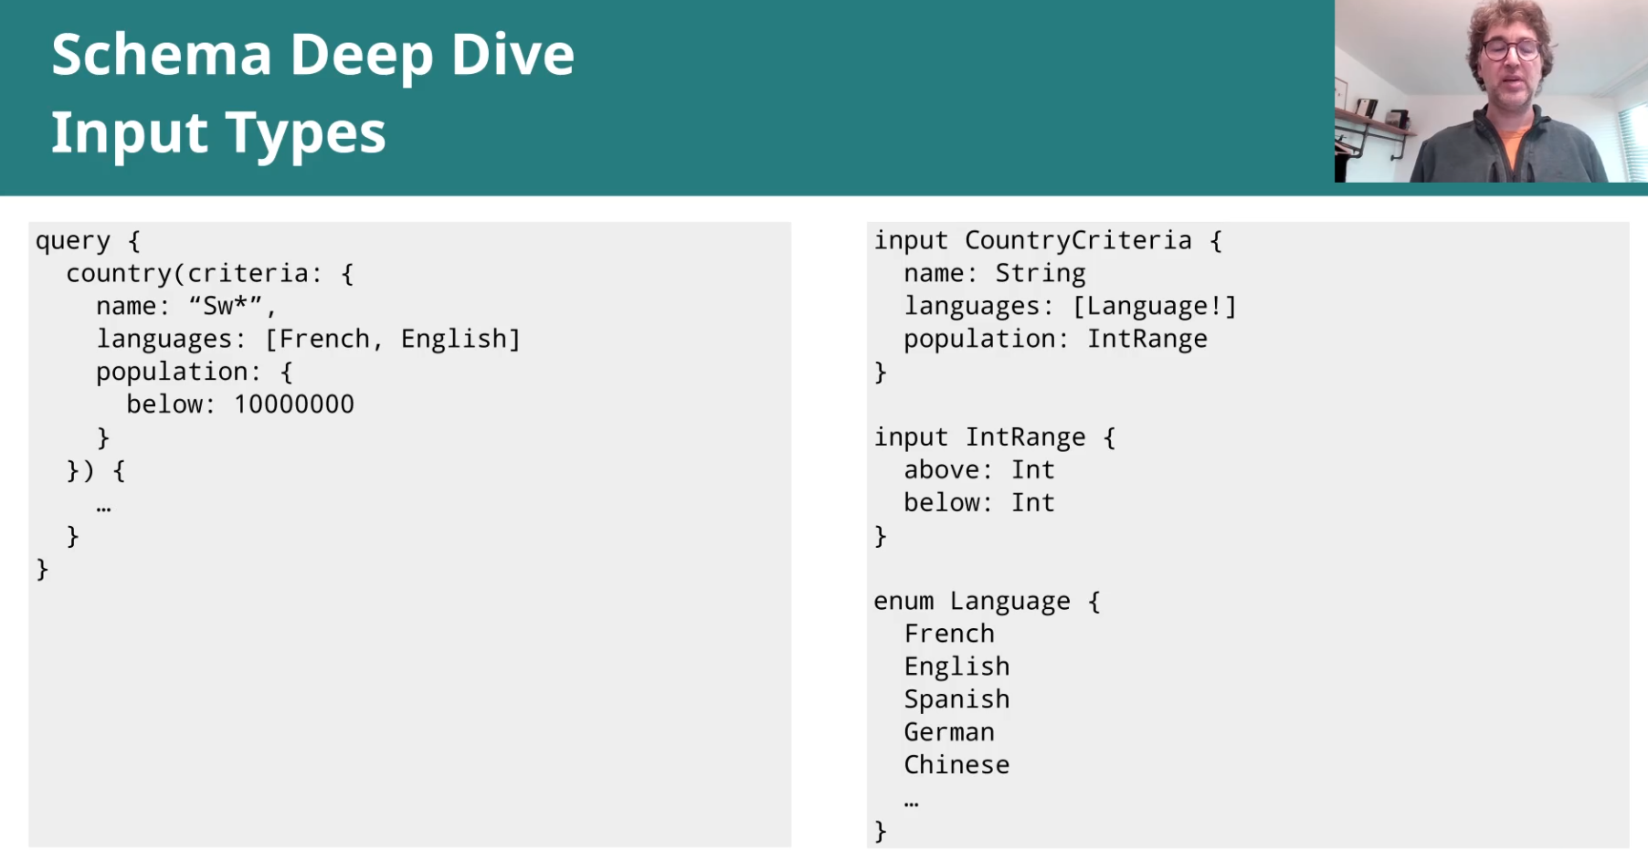

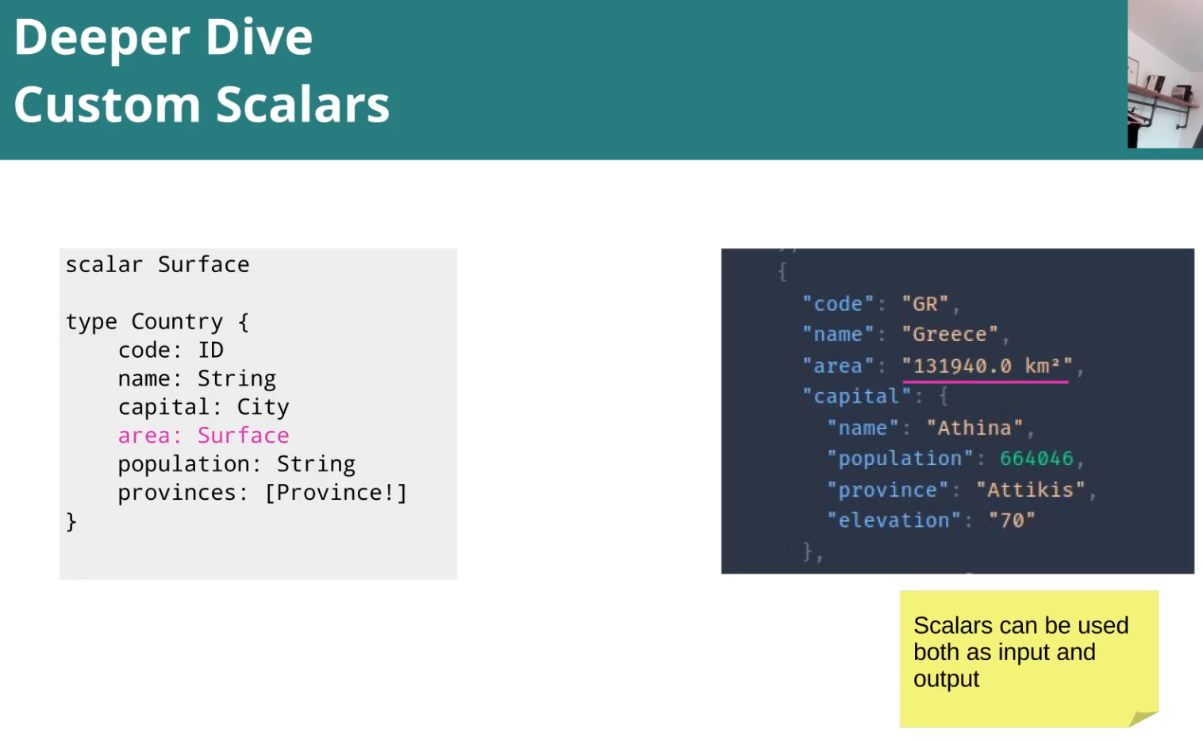

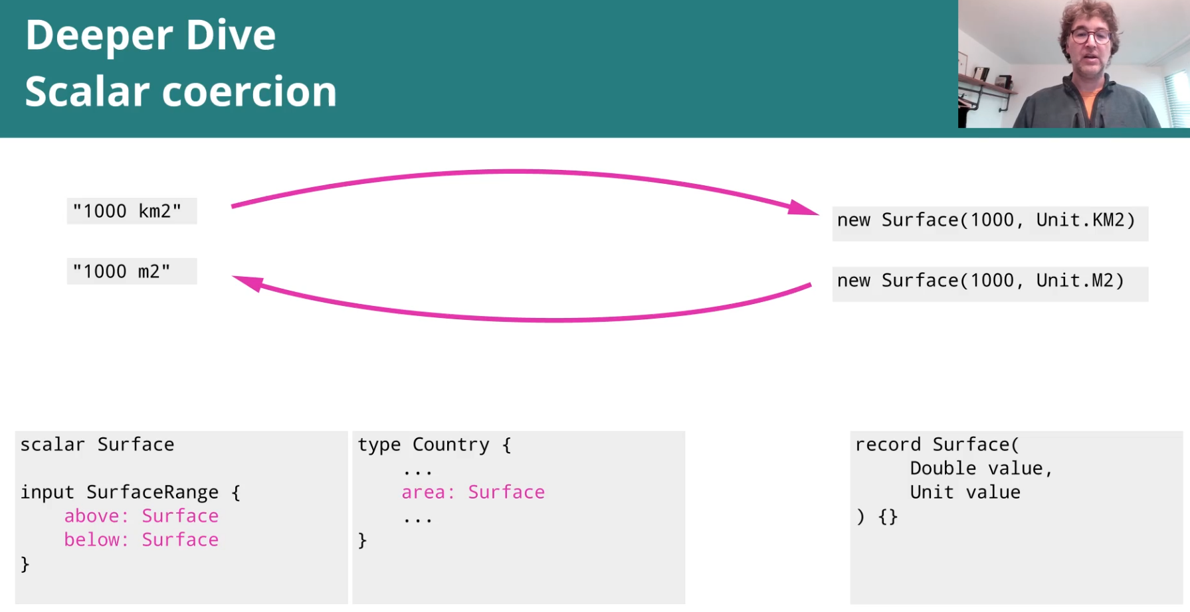

Hands On: Add Criteria to Select Countries

- Add enum Continent to the schema:
Schema
type Query {
countries(continent: Continent): [Country]
}

enum Continent {
Europe
Asia
Africa
SouthAmerica
NorthAmerica
Oceania
}

Now we have an error in the query:
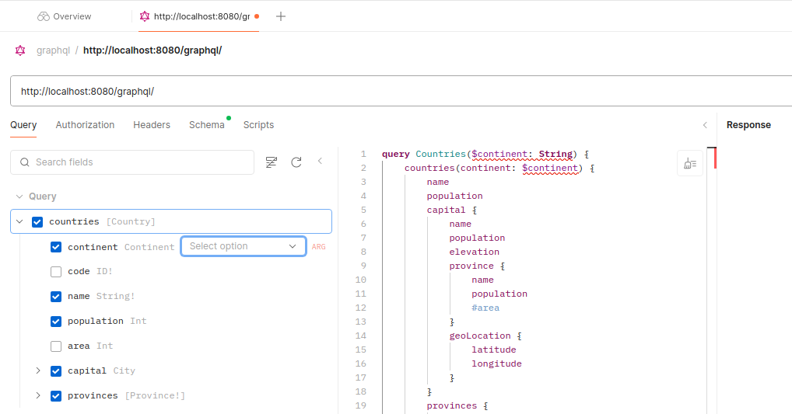

Now we must set it as an Enum (Continent)

Important!!! The enum must be wired the same way as the data fetchers:
private RuntimeWiring buildRuntimeWiring(Connection dbConnection) {
return RuntimeWiring.newRuntimeWiring()
//Wire Enums
.type("Continent", builder -> builder.enumValues(new NaturalEnumValuesProvider<>(Continent.class)))
...

- Add criteria to search countries:

Schema
type Query {
countries(continent: CountryCriteria): [Country]
}

input IntRange {
above: Int
below: Int
}
input CountryCriteria {
continent: Continent
populationRange: IntRange
}

…
(See the code)

Hands On: Add Criteria to Select Provinces

…

Hands On: Adding Custom Scalars

Declare scalar in schema:
scalar Surface

…

type Country {
code: ID!
name: String!
population: Int
area: Surface
capital: City
provinces: [Province!]
}

…

Wire it in GraphQLRuntime:
private RuntimeWiring buildRuntimeWiring(Connection dbConnection) {
return RuntimeWiring.newRuntimeWiring()
// Wire Scalars
.scalar(GraphQLScalarType.newScalar()
.name("Surface")
.description("It represents a surface: an amount and an unit (m² or km²)")
.coercing(new SurfaceCoercing() {
})
.build())
...

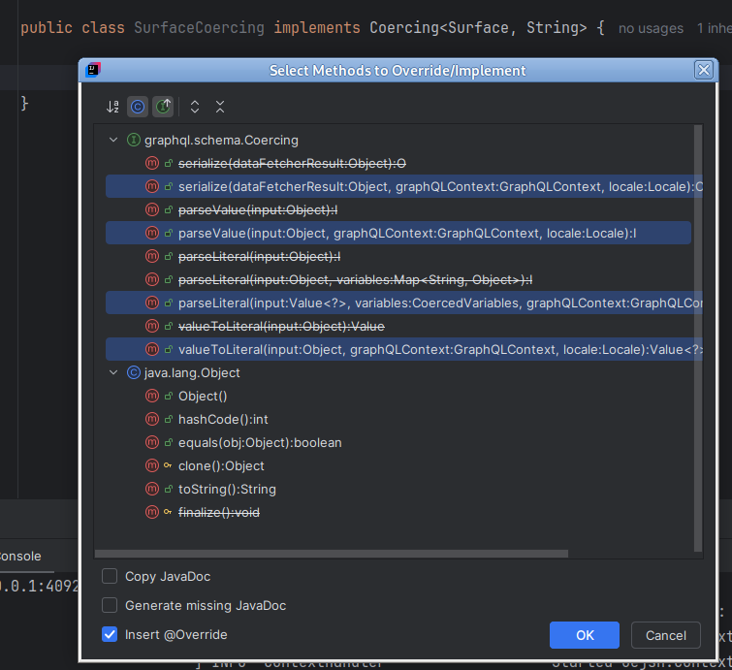

Now we can see the surface like this:
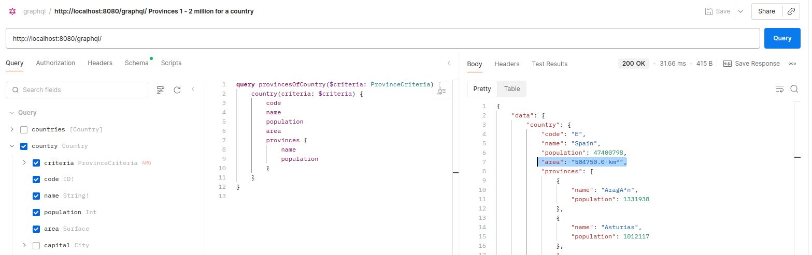

Part 2: Unions and Interfaces
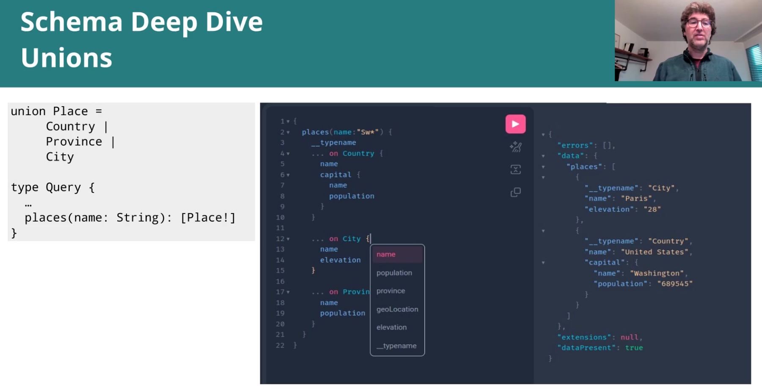
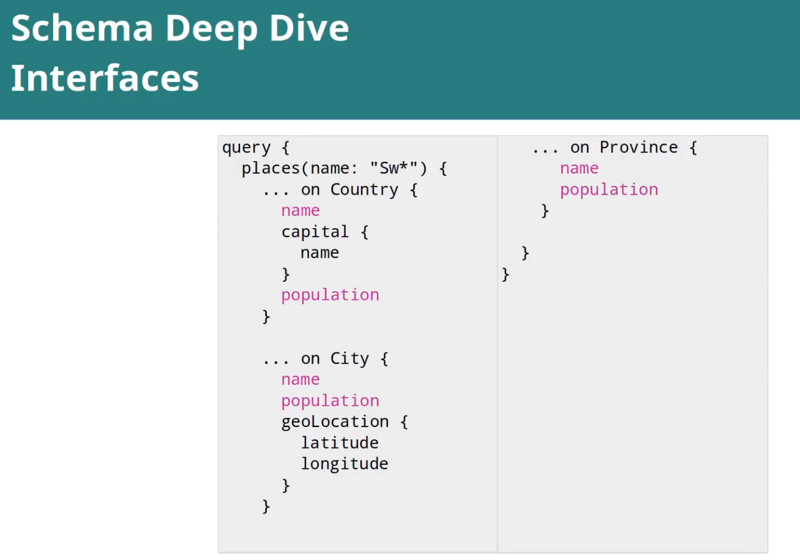

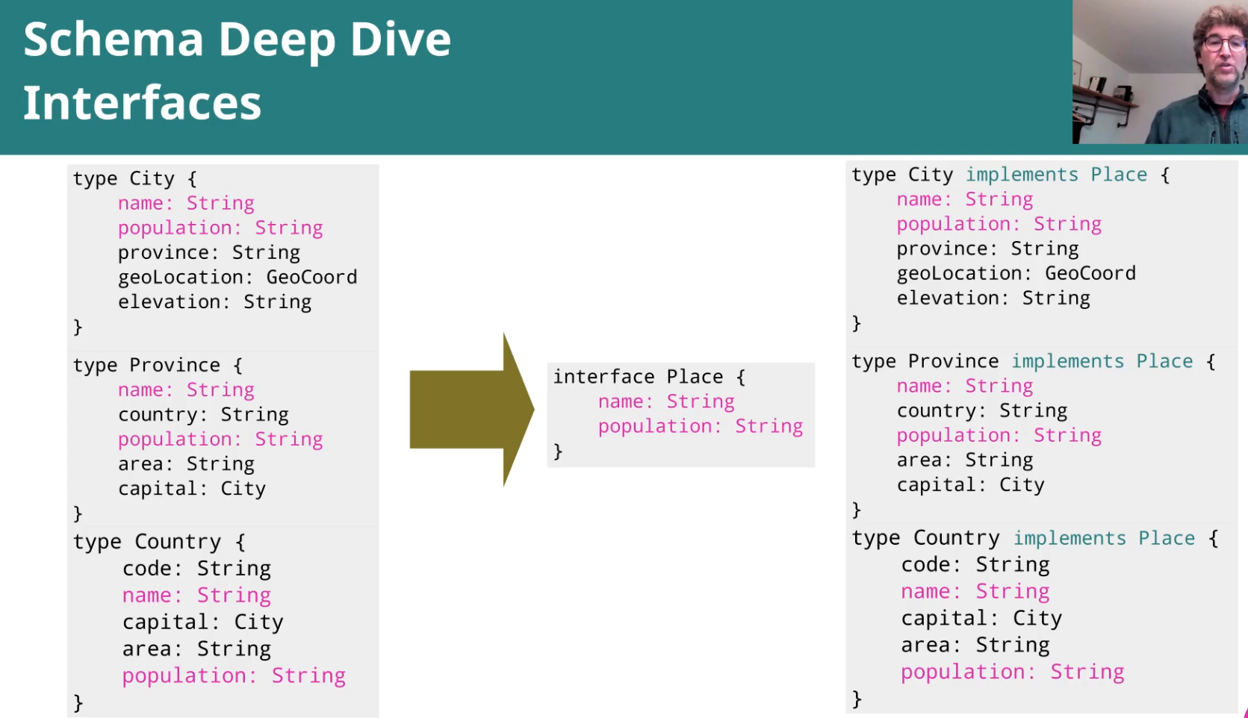

Hands On: Implementing places entry point

Add union Place in schema:
type Query {
countries(criteria: CountryCriteria): [Country]
country(criteria: ProvinceCriteria): Country
provinces(criteria: ProvinceCriteria): [Province]
places(criteria: PlaceCriteria): [Place]
}
…

input PlaceCriteria {
name: String
}
…

union Place = Country | Province | City

Add DataFetcher .. (similar to DBCountriesDataFetcher)
We develope the union query in the Database Navigator:
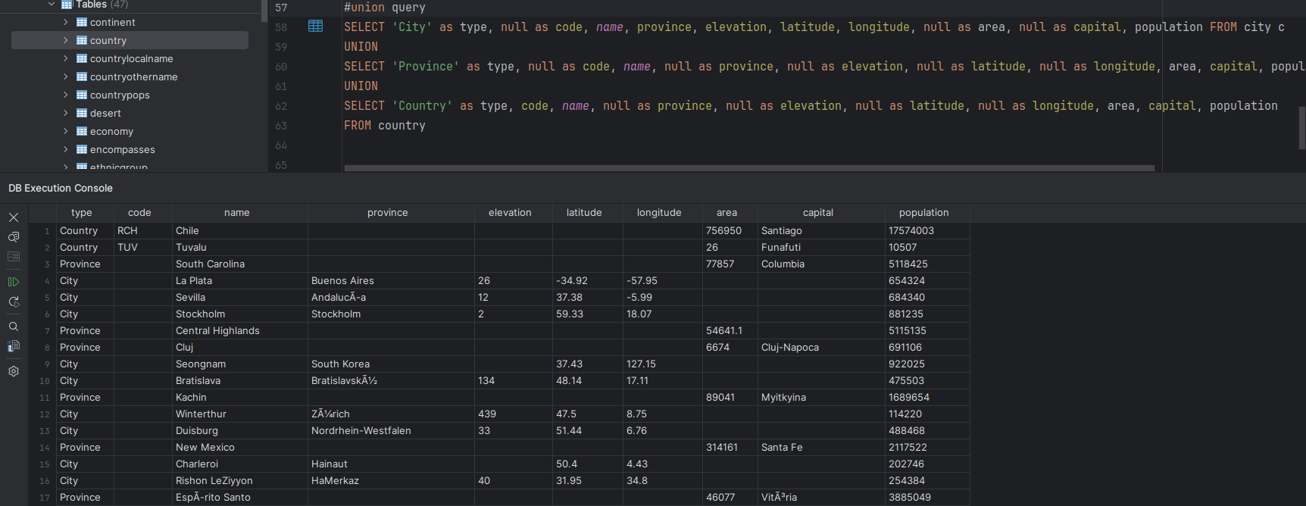

And using “with“, we can filter on the union query:
#union query
WITH place AS (
SELECT 'City' as type, null as code, name, province, elevation, latitude, longitude, null as area, null as capital, population FROM city c
UNION
SELECT 'Province' as type, null as code, name, null as province, null as elevation, null as latitude, null as longitude, area, capital, population FROM province
UNION
SELECT 'Country' as type, code, name, null as province, null as elevation, null as latitude, null as longitude, area, capital, population
FROM country
)
SELECT *
FROM place
WHERE name like 'Ber%'

We can bring that query now to the DBPlacesDataFetcher:

...
private PreparedStatement queryWithCriteria(Map<String, Object> criteria) throws SQLException {
StringBuilder stringBuilder = new StringBuilder();
stringBuilder.append("""
WITH place AS (
SELECT 'City' as type, null as code, name, province, elevation, latitude, longitude, null as area, null as capital, population
FROM city c
UNION
SELECT 'Province' as type, null as code, name, null as province, null as elevation, null as latitude, null as longitude, area, capital, population
FROM province
UNION
SELECT 'Country' as type, code, name, null as province, null as elevation, null as latitude, null as longitude, area, capital, population
FROM country
)
SELECT *
FROM place
WHERE name like ?
""");
...

To wire the results for the union, we need to set the wiring and a type resolver:

…
private RuntimeWiring buildRuntimeWiring(Connection dbConnection) {
return RuntimeWiring.newRuntimeWiring()
…
//Wire type resolvers for unions and interfaces
.type("Place",builder → builder.typeResolver(new PojoClassTypeResolver()))
…
// also the query, of course
.type("Query",builder->builder.dataFetcher("places",new DBPlacesDataFetcher(dbConnection)))
…

The type resolver, so we can pass from the Java class/type to the GraphQL type:

public class PojoClassTypeResolver implements TypeResolver {
@Override
public GraphQLObjectType getType(TypeResolutionEnvironment env) {
var concreteObject = env.getObject();
return env.getSchema().getObjectType(concreteObject.getClass().getSimpleName());
}
}

And now we get for example cities and provinces at the same time that start by “Ber“:

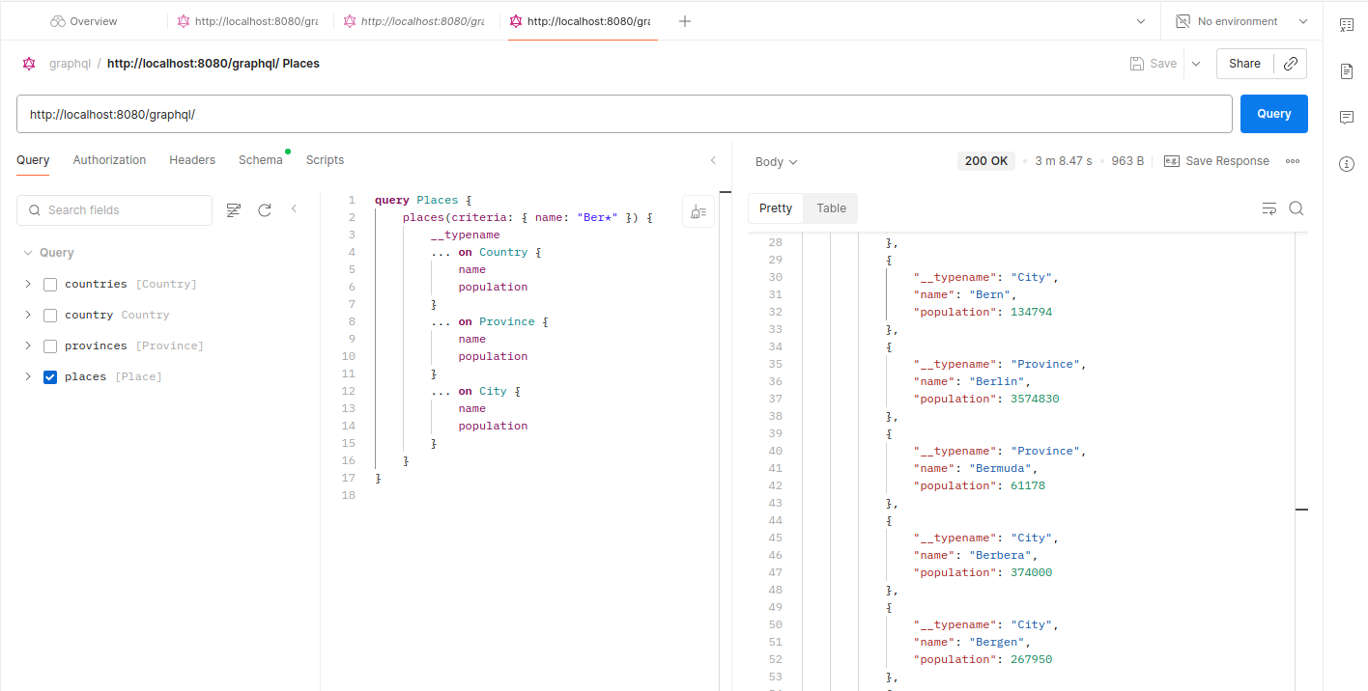

Now we remove the union, and we define Place as an interface:

interface Place {
name: String!
population: Int
}
type Country implements Place {
code: ID!
name: String!
population: Int
area: Surface
capital: City
provinces: [Province!]
}
type City implements Place {
name: String!
population: Int
geoLocation: GeoCoord
elevation: Int
province: Province
}
type Province implements Place {
name: String!
population: Int
capital: City
area: Int
}

The code works the same!
The query returns the same!

The difference: we can put the common fields outside:

query Places {
places(criteria: { name: "Ber*" }) {
__typename
name
population
... on Country {
capital {
name
}
}
... on Province {
area
}
... on City {
elevation
}

}
}

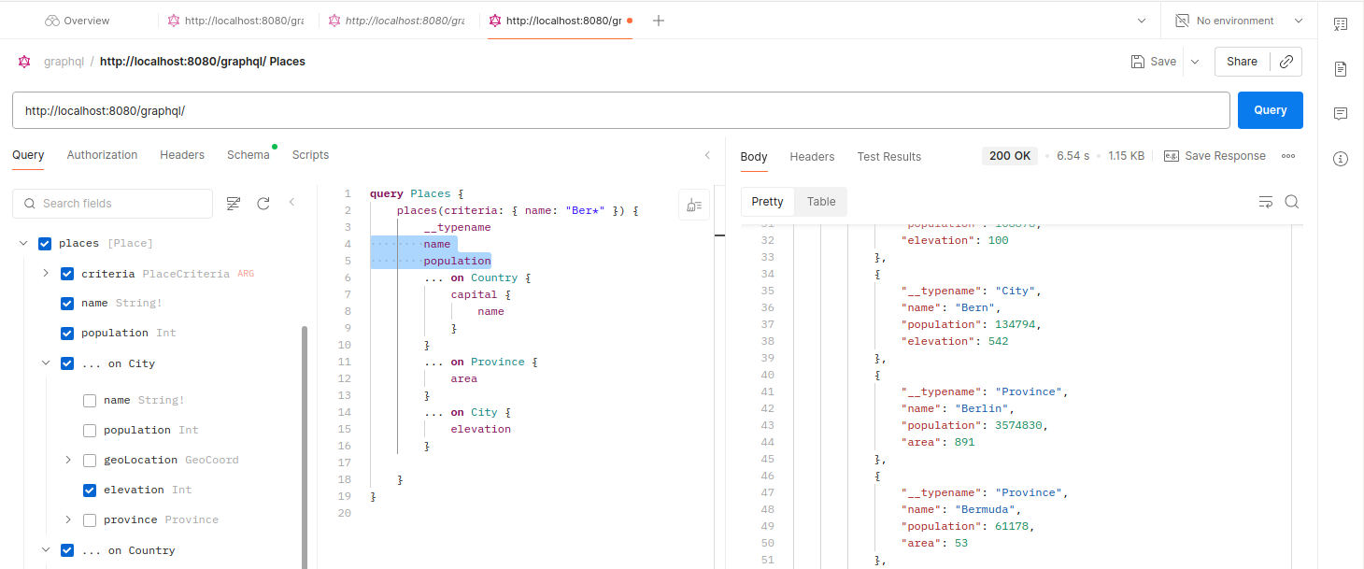

query Places {
places(criteria: { name: "Bar*" }) {
__typename
name
population
}
}

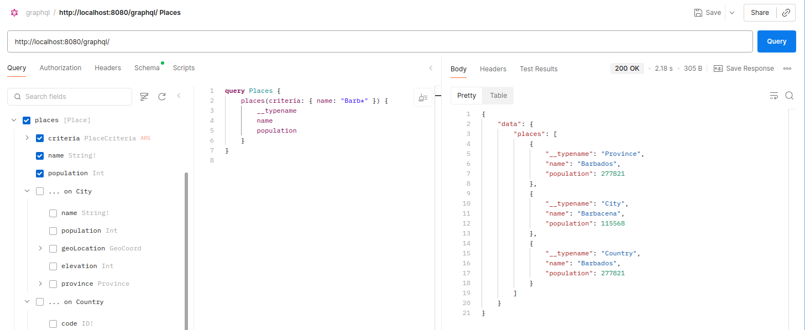

Section 7 – Schema Directives and Documentation

Hands-On: Adding documentation
type Query {
"""
It allows to retrieve a list of countries that match the specified criteria
"""
countries(criteria: CountryCriteria): [Country]
"""
It allows to retrieve a country with a list of its provinces that match the specified criteria
"""
country(criteria: ProvinceCriteria): Country

...

Just like that …

Section 8 – Quieres Deep Dive

Query constructs

Variables:
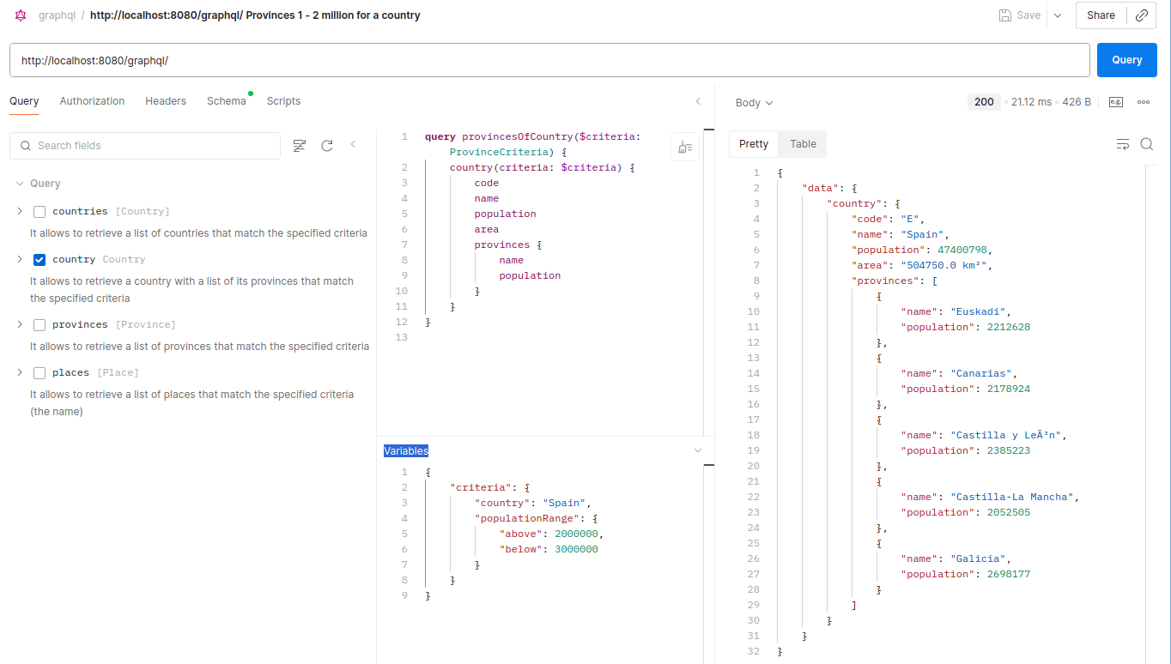

Query directives (operation directives?):

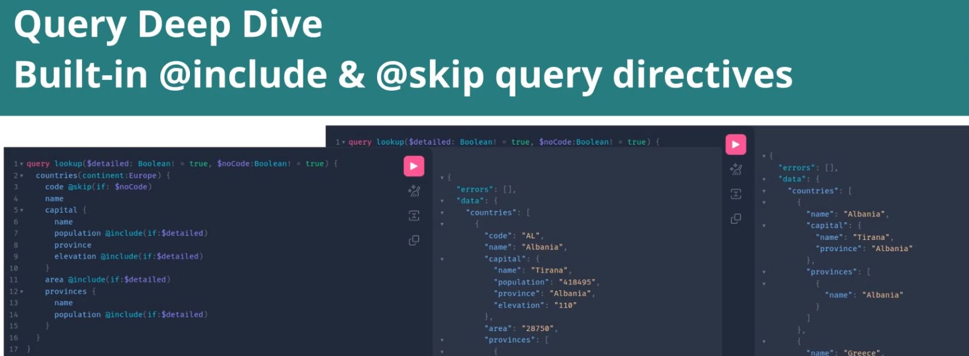
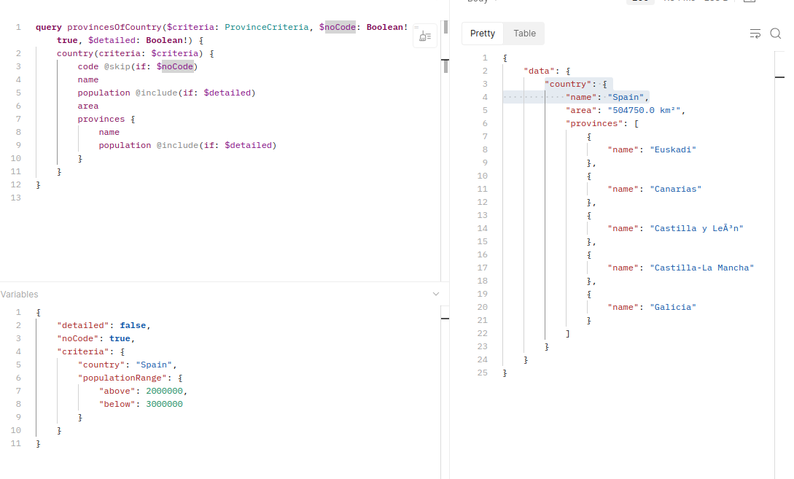

Aliases:

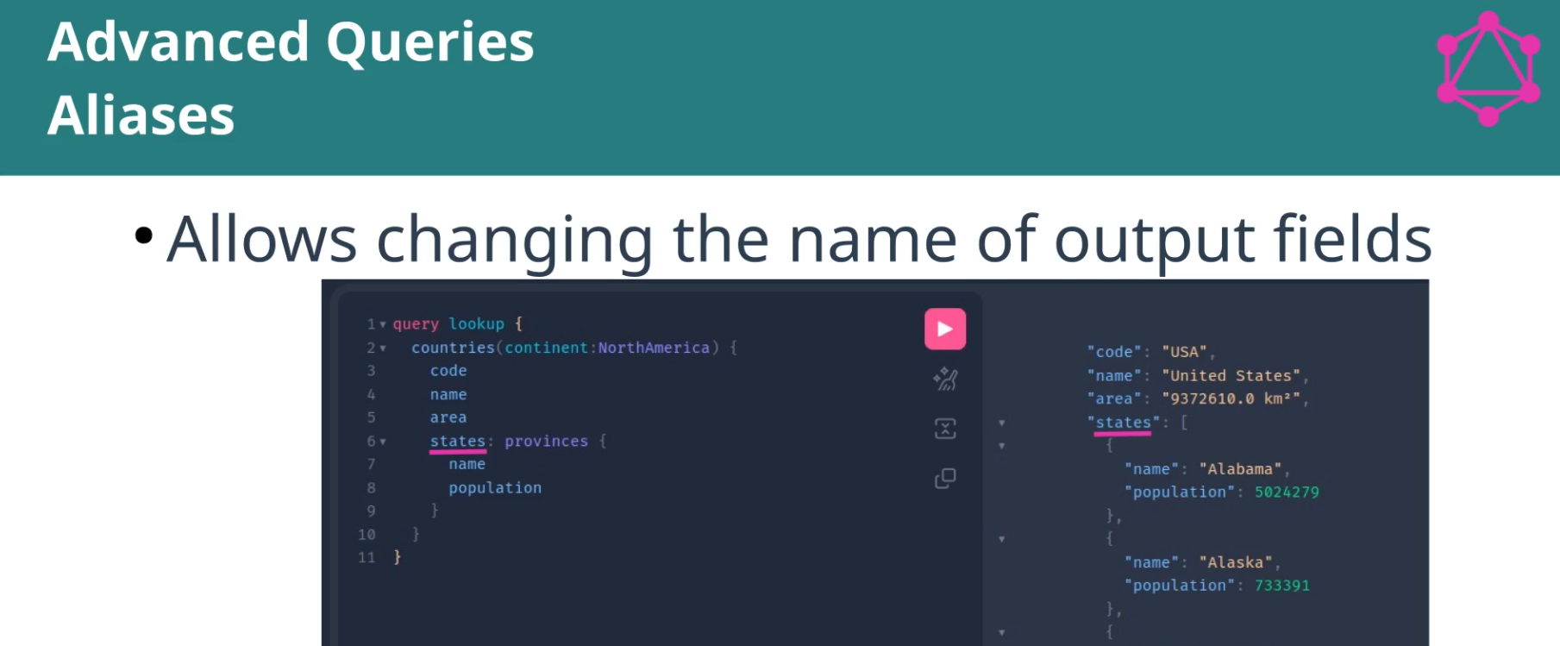

Now in the output we have the right name for Spain:

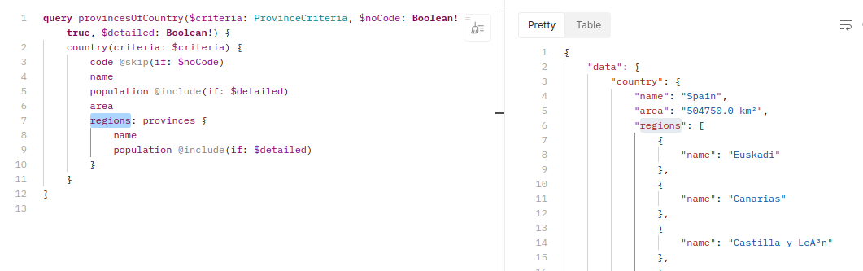

Fragments:
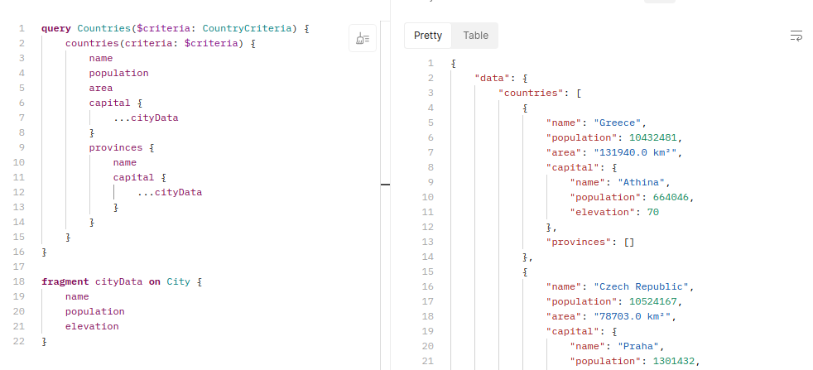

(DataFetcher for this query must be fixed!!!!)

Assignment 5: Exercise your querying skills

query Assignment5_1($minPopulation: Int, $maxPopulation: Int) {
countries(
criteria: {
populationRange: { above: $minPopulation, below: $maxPopulation }
continent: Europe
}
) {
code
name
population
area
}
}

query Assignment5_2($startsBy: String) {
places(criteria: { name: $startsBy }) {
__typename
name
population
... on Country {
capital {
...cityData
}
}
... on Province {
capital {
...cityData
}
}
... on City {
...cityData
}
}
}

fragment cityData on City {
name
geoLocation {
latitude
longitude
}
}

query Assignment5_3($startsBy: String) {
places(criteria: { name: $startsBy }) {
type: __typename
name
population
}
}

Variables:

{
"minPopulation": 10000000,
"maxPopulation": 20000000,
"startsBy": "Z*"
}

Section 9 – Schema Introspection

Schema Introspection

We get it for free :)
Whole schema:
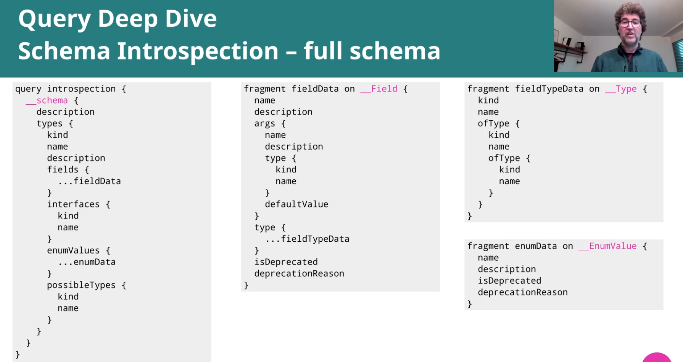

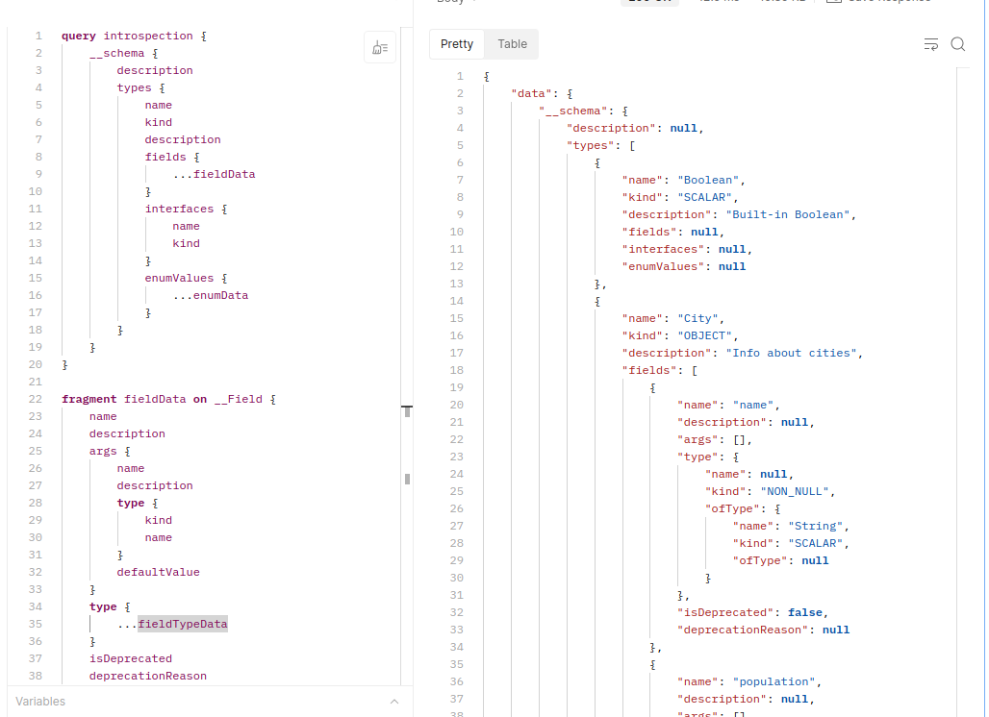
Or we can query also just one element of the schema:

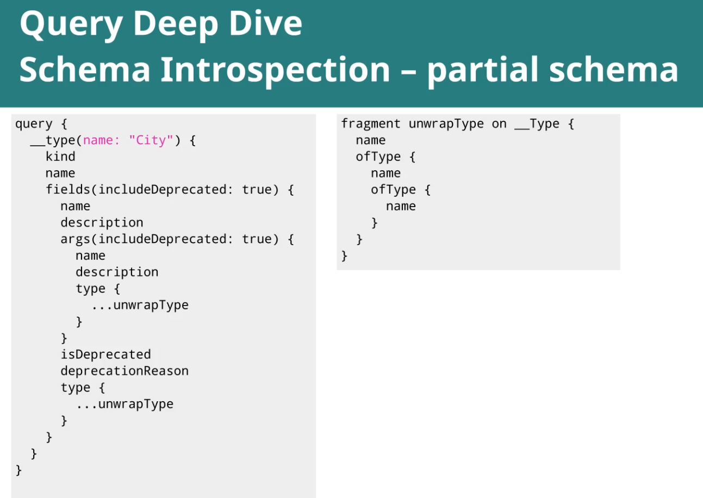

Assignment 6: Querying the GraphQL Schema through introspection

query introspectionPlace {
__type(name: "Place") {
name
kind
fields(includeDeprecated: true) {
name
description
type {
...unwrapType
}
}
ofType {
name
description
__typename
}
possibleTypes {
name
__typename
}
}
}

fragment unwrapType on __Type {
name
ofType {
name
ofType {
name
}
}
}

query solution {
__type(name:"Place") {
name
possibleTypes {
name
fields {
name
type {
kind
name
ofType {
kind
name
ofType {
kind
name
}
}
}
}
}
}
}

Section 10 – Schema Evolution

Managing Schema Changes Smoothly
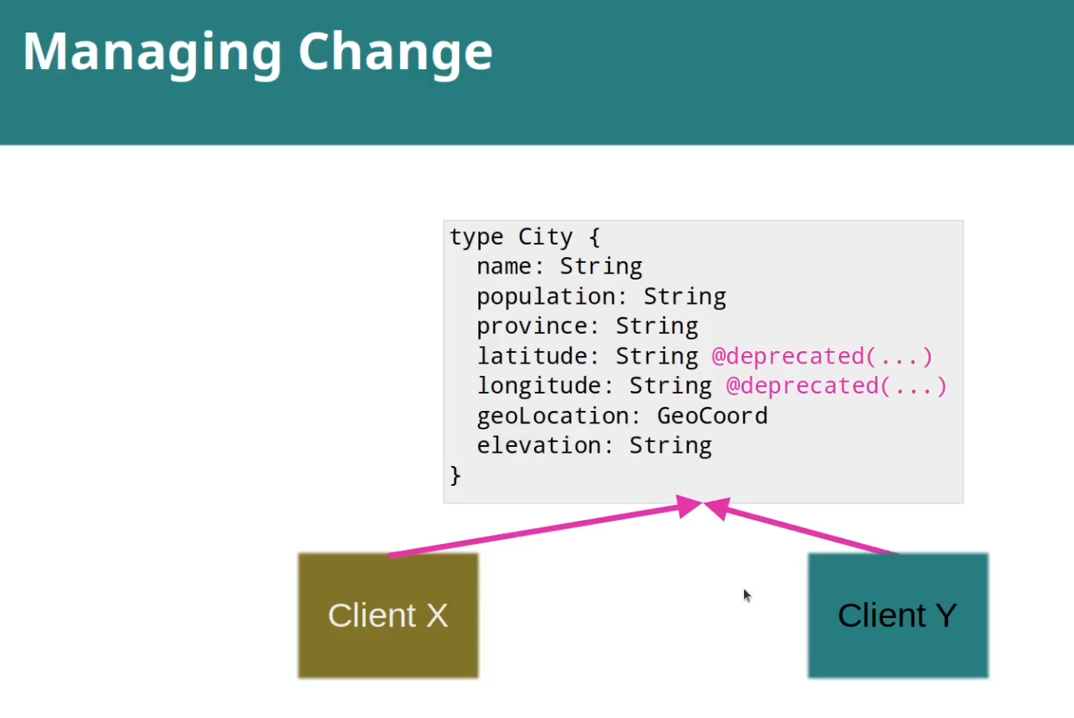

Client “X“ started using latitude and longitude. Ok, he can go on.
But new Client “Y“, he can start using the field geoLocation.

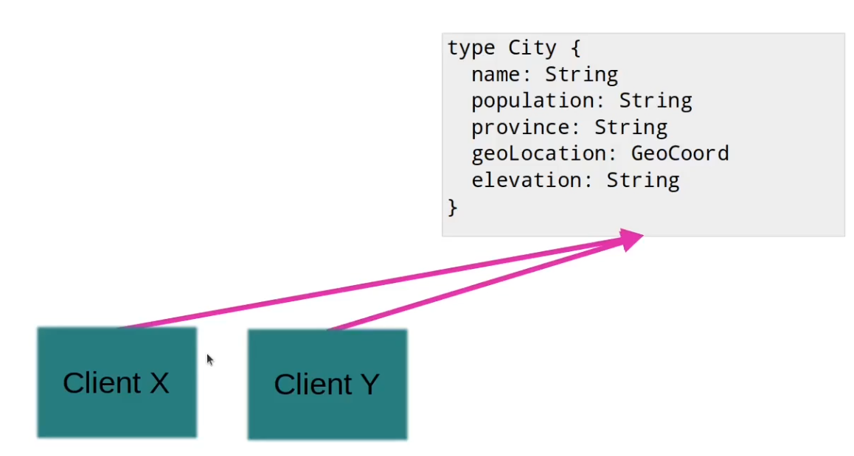

But when that client is prepared to use the new field, the old one/es can be removed.

Hands-On: Change schema keeping old fields wired

Schema:
"""
Info about cities
"""
type City implements Place {
name: String!
population: Int
latitude: Float @deprecated(reason: "Use geoLocation")
longitude: Float @deprecated(reason: "Use geoLocation")
geoLocation: GeoCoord
elevation: Int
province: Province
}

Wiring the deprecated fields:

…
.type("City", builder -> builder
.dataFetcher("province", new DBProvinceFromCapitalDataFetcher(dbConnection))
//wire old fields for backwards compatibility
.dataFetcher("latitude", env -> {
City city = env.getSource();
return Optional.ofNullable(city).map(City::geoLocation).map(GeoCoord::latitude)
.orElse(null);
})
.dataFetcher("longitude", env -> {
City city = env.getSource();
return Optional.ofNullable(city).map(City::geoLocation).map(GeoCoord::longitude)
.orElse(null);
})
)
…

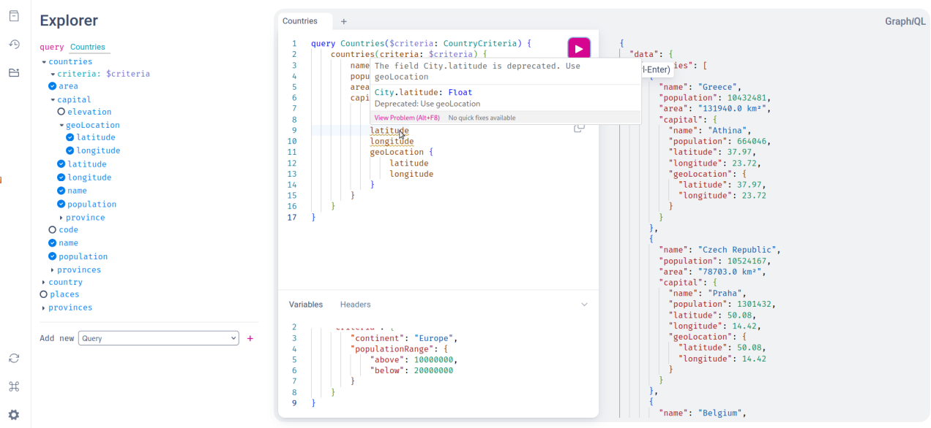

Section 11 – Schema via Code

Managing Schema via Code
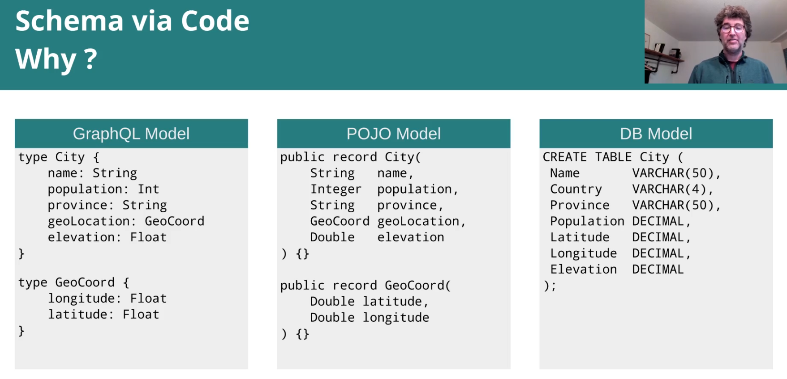
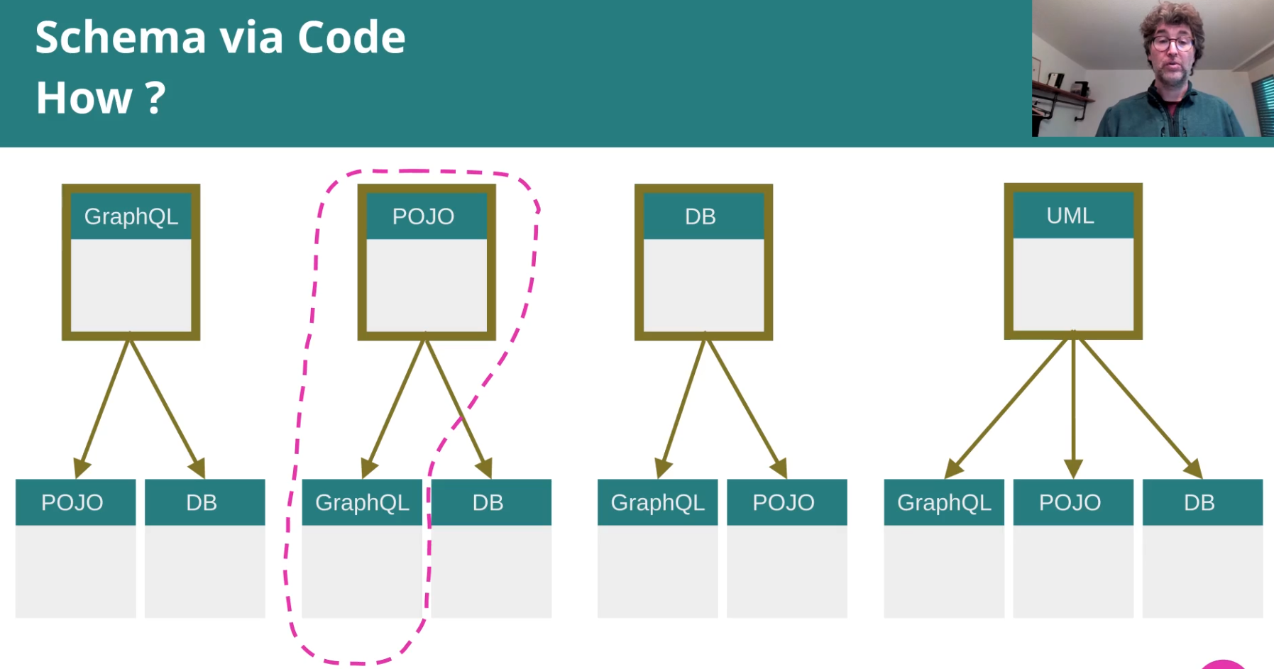

Hands-On: Populating pieces of GraphQL schema via POJO introspection

(We continue on the branch “addingDeprecatedFields“)
Remove Province from the schema. We will add it via code:

…
private TypeDefinitionRegistry buildTypeDefinitionRegistry() throws IOException {
SchemaParser schemaParser = new SchemaParser();
TypeDefinitionRegistry typeRegistry;
try(InputStream is = GraphQLRuntime.class.getResourceAsStream("/schema.graphql")) {
assert is != null;
Reader schemaReader = new InputStreamReader(is, StandardCharsets.UTF_8);
typeRegistry = schemaParser.parse(schemaReader);
}
//But we add a "new" type
/*
#type Province implements Place {
# name: String!
# population: Int
# capital: City
# area: Int
#}
*/
typeRegistry.add(ObjectTypeDefinition.newObjectTypeDefinition()
.name("Province")
.description(new Description("Added via code in GraphQLRuntime",null,false))
.fieldDefinition(FieldDefinition.newFieldDefinition()
.name("name")
.type(new NonNullType(new TypeName("String")))
.build())
.fieldDefinition(FieldDefinition.newFieldDefinition()
.name("population")
.type(new NonNullType(new TypeName("Int")))
.build())
.fieldDefinition(FieldDefinition.newFieldDefinition()
.name("capital")
.type(new NonNullType(new TypeName("City")))
.build())
.fieldDefinition(FieldDefinition.newFieldDefinition()
.name("area")
.type(new NonNullType(new TypeName("Int")))
.build())
.implementz(new TypeName("Place"))
.build()
);
return typeRegistry;
}
…

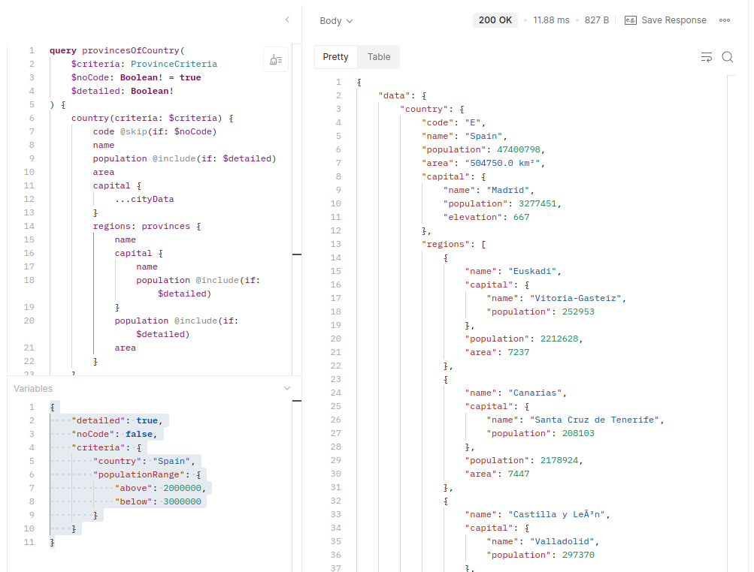
It works the same of
course.

But if we move that code to a helper class, things get more complicated (because we want a generic version using introspection, not just that code in another place):
public class TypeHelper {
public static ObjectTypeDefinition provinceDefinitionOf(Class<Province> provinceClass) {
return ObjectTypeDefinition.newObjectTypeDefinition()
.name("Province")
… «same code as before»
}
/*
* Using introspection
*/
public static ObjectTypeDefinition objectDefinitionOf(Class<?> clazz) {
ObjectTypeDefinition.Builder definitionBuilder = ObjectTypeDefinition.newObjectTypeDefinition()
.name(clazz.getSimpleName())
.description(new Description("Added via code",null,false));
for (var field : clazz.getDeclaredFields()) {
Type<?> gqlType = fromJavaClassToGraphQLType(field.getType());
definitionBuilder.fieldDefinition(
FieldDefinition.newFieldDefinition()
.name(field.getName())
.type(gqlType)
.build());
}
for (var interfaz : clazz.getInterfaces()) {
definitionBuilder.implementz(new TypeName(interfaz.getSimpleName()));
}
return definitionBuilder.build();
}
private static Type<?> fromJavaClassToGraphQLType(Class<?> javaType) {
if (Collection.class.isAssignableFrom(javaType)) {
return new ListType((new TypeName(javaType.getSimpleName())));
} else if (Integer.class.isAssignableFrom(javaType) || int.class.isAssignableFrom(javaType) ||
Long.class.isAssignableFrom(javaType) || long.class.isAssignableFrom(javaType)) {
return new TypeName("Int");
} else if (Double.class.isAssignableFrom(javaType) || double.class.isAssignableFrom(javaType)) {
return new TypeName("Float");
} else {
return new TypeName(javaType.getSimpleName());
}
}
}

With that code, we get an error because the field Province in the schema is not null, but it is nullable in the Java class.
To solve that, we make that field name non nullable:
public record Province(
@NonNull
String name,
Integer population,
String capital,
Integer area
) implements Place {}

And in the helper class we add:

/*
* Using introspection
*/
public static ObjectTypeDefinition objectDefinitionOf(Class<?> clazz) {
…

// make the field non-null if the Java field is required
if (isRequired(field)) {
gqlType = new NonNullType(gqlType);
}

…
}

private static boolean isRequired(java.lang.reflect.Field field) {
//primitive types are always required
if (field.getType().isPrimitive()) {
return true;
}
//look for a @NonNull (or any other marker -dependencies needed in that case)
return field.isAnnotationPresent(org.springframework.lang.NonNull.class)
// || field.isAnnotationPresent(javax.validation.constraints.NotNull.class)
// || field.isAnnotationPresent(org.jetbrains.annotations.NotNull.class)
;
}

…

That problem is solved.

Now we have another problem:

{
"errors": [
{
"message": "Validation error (SubselectionNotAllowed@[country/provinces/capital]) : Subselection not allowed on leaf type 'String' of field 'capital'",
"locations": [
...
}

This happens because in the Java class Province the field “capital“ is defined as a String, but in the schema it is a City.
We can use a custom annotation to solve this:

package org.francd.model;
import java.lang.annotation.Retention;
import java.lang.annotation.RetentionPolicy;
@Retention(RetentionPolicy.RUNTIME)
public @interface GraphqlType {
String value();
}

Now the Province looks like this (we annotate capital with the GraphQL type “City“)

package org.francd.model;
import org.springframework.lang.NonNull;
public record Province(
@NonNull
String name,
Integer population,
@GraphqlType("City")
String capital,
Integer area
) implements Place {}

So in the helper class we assign the right type for the field capital (because that field is annotated now):

var typeAnnotation = field.getAnnotation(GraphqlType.class);
Type<?> gqlType = typeAnnotation != null ?
new TypeName(typeAnnotation.value()) : fromJavaClassToGraphQLType(field.getType());

And now everything is fine again:

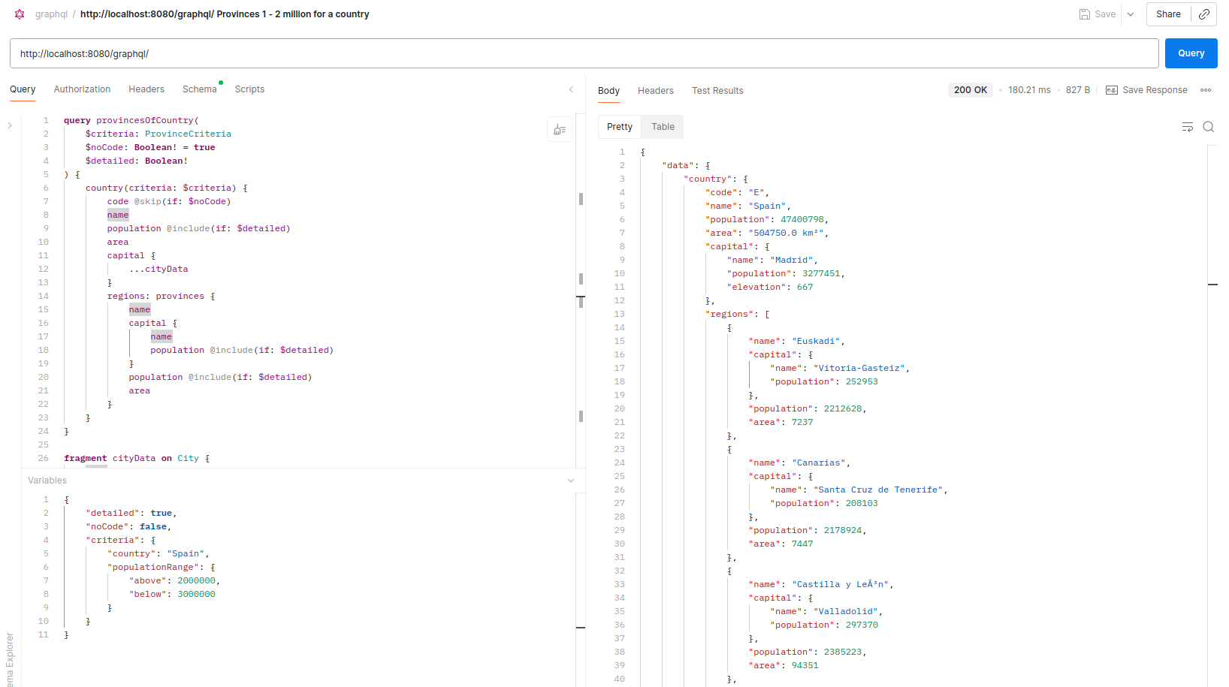

Assignment 8: Generate the City type via code

Simply remove the type from the schema, and add the City.class to be treated by the type helper:

// We add also the City
typeRegistry.add(TypeHelper.objectDefinitionOf(City.class));

Also modify City as we did with Province before:

public record City(
@NonNull
String name,
Integer population,
GeoCoord geoLocation,
Integer elevation,
@GraphqlType("Province")
String province
) implements Place {}

Section 12 – Instrumentation

Instrumentation
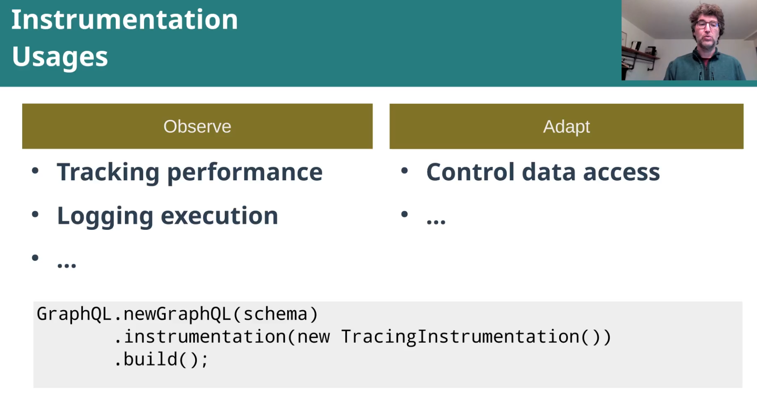

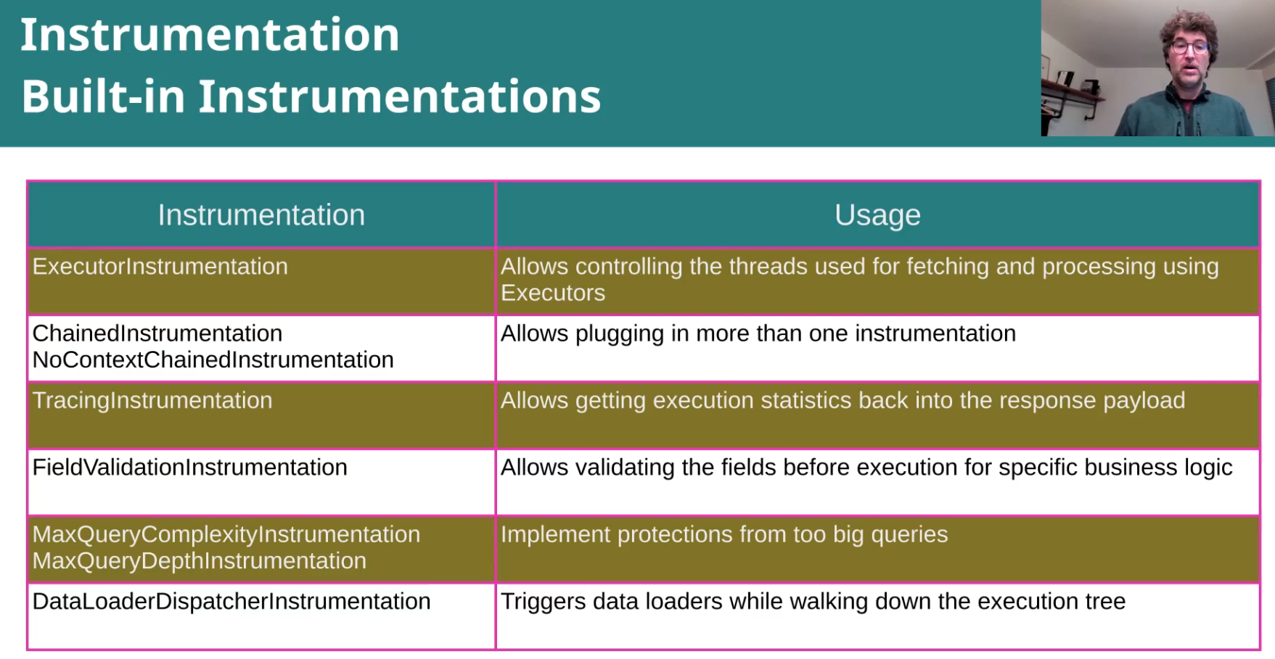

Hands-On: Logging Query Execution via Instrumentation

[ Better not to use in production environments ]

Before building the GraphQL object, we can configure many things for it. Including instrumentation of course:
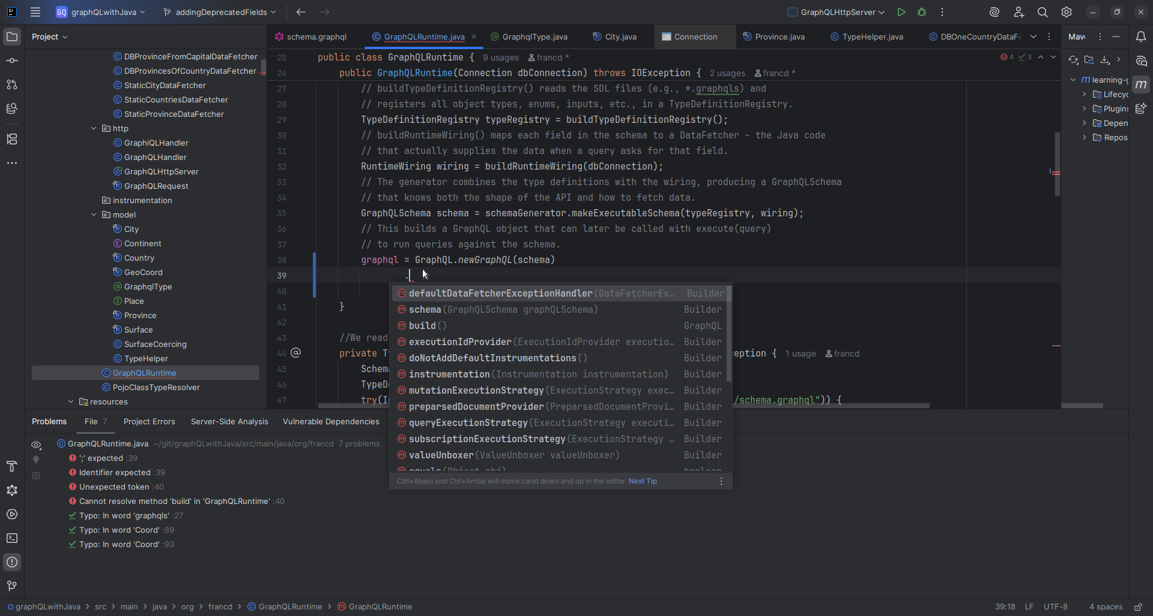
Add instrumentation class:
@SuppressWarnings("NullableProblems")
public class LoggingInstrumentation extends SimplePerformantInstrumentation {
private static final Logger LOGGER = LoggerFactory.getLogger(LoggingInstrumentation.class);
@Override
public InstrumentationContext<ExecutionResult> beginExecution(InstrumentationExecutionParameters parameters, InstrumentationState state) {
return logState("execution");
}
...

And configure GraphQLRuntime with it:

public GraphQLRuntime(Connection dbConnection) throws IOException {
SchemaGenerator schemaGenerator = new SchemaGenerator();
TypeDefinitionRegistry typeRegistry = buildTypeDefinitionRegistry();
RuntimeWiring wiring = buildRuntimeWiring(dbConnection);
GraphQLSchema schema = schemaGenerator.makeExecutableSchema(typeRegistry, wiring);
graphql = GraphQL.newGraphQL(schema)
.instrumentation(new LoggingInstrumentation())
.build();
}

Logs now:
2025-10-24 19:22:10,169 [qtp178259104-37 ] INFO LoggingInstrumentation - Instrumenting state execution input
2025-10-24 19:22:10,170 [qtp178259104-37 ] INFO LoggingInstrumentation - Starting state [execution]
2025-10-24 19:22:10,170 [qtp178259104-37 ] INFO LoggingInstrumentation - Instrumenting schema
2025-10-24 19:22:10,170 [qtp178259104-37 ] INFO LoggingInstrumentation - Starting state [parsing]
2025-10-24 19:22:10,176 [qtp178259104-37 ] INFO LoggingInstrumentation - Completed state [parsing].
2025-10-24 19:22:10,176 [qtp178259104-37 ] INFO LoggingInstrumentation - Instrumenting document and variables
2025-10-24 19:22:10,176 [qtp178259104-37 ] INFO LoggingInstrumentation - Starting state [validating]
2025-10-24 19:22:10,178 [qtp178259104-37 ] INFO LoggingInstrumentation - Completed state [validating].
2025-10-24 19:22:10,178 [qtp178259104-37 ] INFO LoggingInstrumentation - Instrumenting execution context
2025-10-24 19:22:10,178 [qtp178259104-37 ] INFO LoggingInstrumentation - Starting state [operation execution]
2025-10-24 19:22:10,179 [qtp178259104-37 ] INFO LoggingInstrumentation - Starting state [null] for path <ExecutionStepInfo{ path=, type=GraphQLObjectType{name='Query', description='null', fieldDefinitionsByName=[countries, country, provinces, places], interfaces=[]}, fieldDefinition=null}>

2025-10-24 19:22:10,182 [qtp178259104-37 ] INFO LoggingInstrumentation - Starting state [field] for path <ExecutionStepInfo{ path=/provinces, type=[Province], fieldDefinition=GraphQLFieldDefinition{name='provinces', type=[Province], arguments=[GraphQLArgument{name='criteria', value=InputValueWithState{state=NOT_SET, value=null}, defaultValue=InputValueWithState{state=NOT_SET, value=null}, type=GraphQLInputObjectType{name='ProvinceCriteria', description='null', fieldMap={country=GraphQLInputObjectField{name='country', description='null', originalType=GraphQLScalarType{name='String', description='Built-in String', coercing=graphql.scalar.GraphqlStringCoercing@7a9056bd}, defaultValue=InputValueWithState{state=NOT_SET, value=null}, definition=InputValueDefinition{name='country', type=TypeName{name='String'}, defaultValue=null, directives=[]}, directives=DirectivesHolder[allDirectivesByName=, allAppliedDirectivesByName=], replacedType=null}, populationRange=GraphQLInputObjectField{name='populationRange', description='null', originalType=[GraphQLInputObjectType], defaultValue=InputValueWithState{state=NOT_SET, value=null}, definition=InputValueDefinition{name='populationRange', type=TypeName{name='IntRange'}, defaultValue=null, directives=[]}, directives=DirectivesHolder[allDirectivesByName=, allAppliedDirectivesByName=], replacedType=null}}, definition=InputObjectTypeDefinition{name='ProvinceCriteria', directives=[], inputValueDefinitions=[InputValueDefinition{name='country', type=TypeName{name='String'}, defaultValue=null, directives=[]}, InputValueDefinition{name='populationRange', type=TypeName{name='IntRange'}, defaultValue=null, directives=[]}]}, directives=DirectivesHolder[allDirectivesByName=, allAppliedDirectivesByName=]}}], dataFetcherFactory=null, description='It allows to retrieve a list of provinces that match the specified criteria', deprecationReason='null', definition=FieldDefinition{name='provinces', type=ListType{type=TypeName{name='Province'}}, inputValueDefinitions=[InputValueDefinition{name='criteria', type=TypeName{name='ProvinceCriteria'}, defaultValue=null, directives=[]}], directives=[]}}}>

2025-10-24 19:22:10,182 [qtp178259104-37 ] INFO LoggingInstrumentation - Starting state [field fetching] for path <ExecutionStepInfo{ path=/provinces, type=[Province], fieldDefinition=GraphQLFieldDefinition{name='provinces', type=[Province], arguments=[GraphQLArgument{name='criteria', value=InputValueWithState{state=NOT_SET, value=null}, defaultValue=InputValueWithState{state=NOT_SET, value=null}, type=GraphQLInputObjectType{name='ProvinceCriteria', description='null', fieldMap={country=GraphQLInputObjectField{name='country', description='null', originalType=GraphQLScalarType{name='String', description='Built-in String', coercing=graphql.scalar.GraphqlStringCoercing@7a9056bd}, defaultValue=InputValueWithState{state=NOT_SET, value=null}, definition=InputValueDefinition{name='country', type=TypeName{name='String'}, defaultValue=null, directives=[]}, directives=DirectivesHolder[allDirectivesByName=, allAppliedDirectivesByName=], replacedType=null}, populationRange=GraphQLInputObjectField{name='populationRange', description='null', originalType=[GraphQLInputObjectType], defaultValue=InputValueWithState{state=NOT_SET, value=null}, definition=InputValueDefinition{name='populationRange', type=TypeName{name='IntRange'}, defaultValue=null, directives=[]}, directives=DirectivesHolder[allDirectivesByName=, allAppliedDirectivesByName=], replacedType=null}}, definition=InputObjectTypeDefinition{name='ProvinceCriteria', directives=[], inputValueDefinitions=[InputValueDefinition{name='country', type=TypeName{name='String'}, defaultValue=null, directives=[]}, InputValueDefinition{name='populationRange', type=TypeName{name='IntRange'}, defaultValue=null, directives=[]}]}, directives=DirectivesHolder[allDirectivesByName=, allAppliedDirectivesByName=]}}], dataFetcherFactory=null, description='It allows to retrieve a list of provinces that match the specified criteria', deprecationReason='null', definition=FieldDefinition{name='provinces', type=ListType{type=TypeName{name='Province'}}, inputValueDefinitions=[InputValueDefinition{name='criteria', type=TypeName{name='ProvinceCriteria'}, defaultValue=null, directives=[]}], directives=[]}}}>

2025-10-24 19:22:10,183 [qtp178259104-37 ] INFO LoggingInstrumentation - Instrumenting data fetcher for step (ExecutionStepInfo{ path=/provinces, type=[Province], fieldDefinition=GraphQLFieldDefinition{name='provinces', type=[Province], arguments=[GraphQLArgument{name='criteria', value=InputValueWithState{state=NOT_SET, value=null}, defaultValue=InputValueWithState{state=NOT_SET, value=null}, type=GraphQLInputObjectType{name='ProvinceCriteria', description='null', fieldMap={country=GraphQLInputObjectField{name='country', description='null', originalType=GraphQLScalarType{name='String', description='Built-in String', coercing=graphql.scalar.GraphqlStringCoercing@7a9056bd}, defaultValue=InputValueWithState{state=NOT_SET, value=null}, definition=InputValueDefinition{name='country', type=TypeName{name='String'}, defaultValue=null, directives=[]}, directives=DirectivesHolder[allDirectivesByName=, allAppliedDirectivesByName=], replacedType=null}, populationRange=GraphQLInputObjectField{name='populationRange', description='null', originalType=[GraphQLInputObjectType], defaultValue=InputValueWithState{state=NOT_SET, value=null}, definition=InputValueDefinition{name='populationRange', type=TypeName{name='IntRange'}, defaultValue=null, directives=[]}, directives=DirectivesHolder[allDirectivesByName=, allAppliedDirectivesByName=], replacedType=null}}, definition=InputObjectTypeDefinition{name='ProvinceCriteria', directives=[], inputValueDefinitions=[InputValueDefinition{name='country', type=TypeName{name='String'}, defaultValue=null, directives=[]}, InputValueDefinition{name='populationRange', type=TypeName{name='IntRange'}, defaultValue=null, directives=[]}]}, directives=DirectivesHolder[allDirectivesByName=, allAppliedDirectivesByName=]}}], dataFetcherFactory=null, description='It allows to retrieve a list of provinces that match the specified criteria', deprecationReason='null', definition=FieldDefinition{name='provinces', type=ListType{type=TypeName{name='Province'}}, inputValueDefinitions=[InputValueDefinition{name='criteria', type=TypeName{name='ProvinceCriteria'}, defaultValue=null, directives=[]}], directives=[]}}})

2025-10-24 19:22:10,185 [qtp178259104-37 ] INFO LoggingInstrumentation - Completed state [field fetching] for path <ExecutionStepInfo{ path=/provinces, type=[Province], fieldDefinition=GraphQLFieldDefinition{name='provinces', type=[Province], arguments=[GraphQLArgument{name='criteria', value=InputValueWithState{state=NOT_SET, value=null}, defaultValue=InputValueWithState{state=NOT_SET, value=null}, type=GraphQLInputObjectType{name='ProvinceCriteria', description='null', fieldMap={country=GraphQLInputObjectField{name='country', description='null', originalType=GraphQLScalarType{name='String', description='Built-in String', coercing=graphql.scalar.GraphqlStringCoercing@7a9056bd}, defaultValue=InputValueWithState{state=NOT_SET, value=null}, definition=InputValueDefinition{name='country', type=TypeName{name='String'}, defaultValue=null, directives=[]}, directives=DirectivesHolder[allDirectivesByName=, allAppliedDirectivesByName=], replacedType=null}, populationRange=GraphQLInputObjectField{name='populationRange', description='null', originalType=[GraphQLInputObjectType], defaultValue=InputValueWithState{state=NOT_SET, value=null}, definition=InputValueDefinition{name='populationRange', type=TypeName{name='IntRange'}, defaultValue=null, directives=[]}, directives=DirectivesHolder[allDirectivesByName=, allAppliedDirectivesByName=], replacedType=null}}, definition=InputObjectTypeDefinition{name='ProvinceCriteria', directives=[], inputValueDefinitions=[InputValueDefinition{name='country', type=TypeName{name='String'}, defaultValue=null, directives=[]}, InputValueDefinition{name='populationRange', type=TypeName{name='IntRange'}, defaultValue=null, directives=[]}]}, directives=DirectivesHolder[allDirectivesByName=, allAppliedDirectivesByName=]}}], dataFetcherFactory=null, description='It allows to retrieve a list of provinces that match the specified criteria', deprecationReason='null', definition=FieldDefinition{name='provinces', type=ListType{type=TypeName{name='Province'}}, inputValueDefinitions=[InputValueDefinition{name='criteria', type=TypeName{name='ProvinceCriteria'}, defaultValue=null, directives=[]}], directives=[]}}}>.

2025-10-24 19:22:10,186 [qtp178259104-37 ] INFO LoggingInstrumentation - Starting state [field fetching] for path <ExecutionStepInfo{ path=/provinces, type=[Province], fieldDefinition=GraphQLFieldDefinition{name='provinces', type=[Province], arguments=[GraphQLArgument{name='criteria', value=InputValueWithState{state=NOT_SET, value=null}, defaultValue=InputValueWithState{state=NOT_SET, value=null}, type=GraphQLInputObjectType{name='ProvinceCriteria', description='null', fieldMap={country=GraphQLInputObjectField{name='country', description='null', originalType=GraphQLScalarType{name='String', description='Built-in String', coercing=graphql.scalar.GraphqlStringCoercing@7a9056bd}, defaultValue=InputValueWithState{state=NOT_SET, value=null}, definition=InputValueDefinition{name='country', type=TypeName{name='String'}, defaultValue=null, directives=[]}, directives=DirectivesHolder[allDirectivesByName=, allAppliedDirectivesByName=], replacedType=null}, populationRange=GraphQLInputObjectField{name='populationRange', description='null', originalType=[GraphQLInputObjectType], defaultValue=InputValueWithState{state=NOT_SET, value=null}, definition=InputValueDefinition{name='populationRange', type=TypeName{name='IntRange'}, defaultValue=null, directives=[]}, directives=DirectivesHolder[allDirectivesByName=, allAppliedDirectivesByName=], replacedType=null}}, definition=InputObjectTypeDefinition{name='ProvinceCriteria', directives=[], inputValueDefinitions=[InputValueDefinition{name='country', type=TypeName{name='String'}, defaultValue=null, directives=[]}, InputValueDefinition{name='populationRange', type=TypeName{name='IntRange'}, defaultValue=null, directives=[]}]}, directives=DirectivesHolder[allDirectivesByName=, allAppliedDirectivesByName=]}}], dataFetcherFactory=null, description='It allows to retrieve a list of provinces that match the specified criteria', deprecationReason='null', definition=FieldDefinition{name='provinces', type=ListType{type=TypeName{name='Province'}}, inputValueDefinitions=[InputValueDefinition{name='criteria', type=TypeName{name='ProvinceCriteria'}, defaultValue=null, directives=[]}], directives=[]}}}>

2025-10-24 19:22:10,186 [qtp178259104-37 ] INFO LoggingInstrumentation - Starting state [field fetching] for path <ExecutionStepInfo{ path=/provinces, type=[Province], fieldDefinition=GraphQLFieldDefinition{name='provinces', type=[Province], arguments=[GraphQLArgument{name='criteria', value=InputValueWithState{state=NOT_SET, value=null}, defaultValue=InputValueWithState{state=NOT_SET, value=null}, type=GraphQLInputObjectType{name='ProvinceCriteria', description='null', fieldMap={country=GraphQLInputObjectField{name='country', description='null', originalType=GraphQLScalarType{name='String', description='Built-in String', coercing=graphql.scalar.GraphqlStringCoercing@7a9056bd}, defaultValue=InputValueWithState{state=NOT_SET, value=null}, definition=InputValueDefinition{name='country', type=TypeName{name='String'}, defaultValue=null, directives=[]}, directives=DirectivesHolder[allDirectivesByName=, allAppliedDirectivesByName=], replacedType=null}, populationRange=GraphQLInputObjectField{name='populationRange', description='null', originalType=[GraphQLInputObjectType], defaultValue=InputValueWithState{state=NOT_SET, value=null}, definition=InputValueDefinition{name='populationRange', type=TypeName{name='IntRange'}, defaultValue=null, directives=[]}, directives=DirectivesHolder[allDirectivesByName=, allAppliedDirectivesByName=], replacedType=null}}, definition=InputObjectTypeDefinition{name='ProvinceCriteria', directives=[], inputValueDefinitions=[InputValueDefinition{name='country', type=TypeName{name='String'}, defaultValue=null, directives=[]}, InputValueDefinition{name='populationRange', type=TypeName{name='IntRange'}, defaultValue=null, directives=[]}]}, directives=DirectivesHolder[allDirectivesByName=, allAppliedDirectivesByName=]}}], dataFetcherFactory=null, description='It allows to retrieve a list of provinces that match the specified criteria', deprecationReason='null', definition=FieldDefinition{name='provinces', type=ListType{type=TypeName{name='Province'}}, inputValueDefinitions=[InputValueDefinition{name='criteria', type=TypeName{name='ProvinceCriteria'}, defaultValue=null, directives=[]}], directives=[]}}}>

2025-10-24 19:22:10,187 [qtp178259104-37 ] INFO LoggingInstrumentation - Starting state [null] for path <ExecutionStepInfo{ path=/provinces[0], type=GraphQLObjectType{name='Province', description='Added via code', fieldDefinitionsByName=[name, population, capital, area], interfaces=[GraphQLInterfaceType{name='Place', description='null', fieldDefinitionsByName=[name, population], typeResolver=null}]}, fieldDefinition=GraphQLFieldDefinition{name='provinces', type=[Province], arguments=[GraphQLArgument{name='criteria', value=InputValueWithState{state=NOT_SET, value=null}, defaultValue=InputValueWithState{state=NOT_SET, value=null}, type=GraphQLInputObjectType{name='ProvinceCriteria', description='null', fieldMap={country=GraphQLInputObjectField{name='country', description='null', originalType=GraphQLScalarType{name='String', description='Built-in String', coercing=graphql.scalar.GraphqlStringCoercing@7a9056bd}, defaultValue=InputValueWithState{state=NOT_SET, value=null}, definition=InputValueDefinition{name='country', type=TypeName{name='String'}, defaultValue=null, directives=[]}, directives=DirectivesHolder[allDirectivesByName=, allAppliedDirectivesByName=], replacedType=null}, populationRange=GraphQLInputObjectField{name='populationRange', description='null', originalType=[GraphQLInputObjectType], defaultValue=InputValueWithState{state=NOT_SET, value=null}, definition=InputValueDefinition{name='populationRange', type=TypeName{name='IntRange'}, defaultValue=null, directives=[]}, directives=DirectivesHolder[allDirectivesByName=, allAppliedDirectivesByName=], replacedType=null}}, definition=InputObjectTypeDefinition{name='ProvinceCriteria', directives=[], inputValueDefinitions=[InputValueDefinition{name='country', type=TypeName{name='String'}, defaultValue=null, directives=[]}, InputValueDefinition{name='populationRange', type=TypeName{name='IntRange'}, defaultValue=null, directives=[]}]}, directives=DirectivesHolder[allDirectivesByName=, allAppliedDirectivesByName=]}}], dataFetcherFactory=null, description='It allows to retrieve a list of provinces that match the specified criteria', deprecationReason='null', definition=FieldDefinition{name='provinces', type=ListType{type=TypeName{name='Province'}}, inputValueDefinitions=[InputValueDefinition{name='criteria', type=TypeName{name='ProvinceCriteria'}, defaultValue=null, directives=[]}], directives=[]}}}>

2025-10-24 19:22:10,187 [qtp178259104-37 ] INFO LoggingInstrumentation - Starting state [field] for path <ExecutionStepInfo{ path=/provinces[0]/population, type=GraphQLScalarType{name='Int', description='Built-in Int', coercing=graphql.scalar.GraphqlIntCoercing@3c654d44}, fieldDefinition=GraphQLFieldDefinition{name='population', type=GraphQLScalarType{name='Int', description='Built-in Int', coercing=graphql.scalar.GraphqlIntCoercing@3c654d44}, arguments=[], dataFetcherFactory=null, description='null', deprecationReason='null', definition=FieldDefinition{name='population', type=TypeName{name='Int'}, inputValueDefinitions=[], directives=[]}}}>

2025-10-24 19:22:10,187 [qtp178259104-37 ] INFO LoggingInstrumentation - Starting state [field fetching] for path <ExecutionStepInfo{ path=/provinces[0]/population, type=GraphQLScalarType{name='Int', description='Built-in Int', coercing=graphql.scalar.GraphqlIntCoercing@3c654d44}, fieldDefinition=GraphQLFieldDefinition{name='population', type=GraphQLScalarType{name='Int', description='Built-in Int', coercing=graphql.scalar.GraphqlIntCoercing@3c654d44}, arguments=[], dataFetcherFactory=null, description='null', deprecationReason='null', definition=FieldDefinition{name='population', type=TypeName{name='Int'}, inputValueDefinitions=[], directives=[]}}}>

2025-10-24 19:22:10,187 [qtp178259104-37 ] INFO LoggingInstrumentation - Instrumenting data fetcher for step (ExecutionStepInfo{ path=/provinces[0]/population, type=GraphQLScalarType{name='Int', description='Built-in Int', coercing=graphql.scalar.GraphqlIntCoercing@3c654d44}, fieldDefinition=GraphQLFieldDefinition{name='population', type=GraphQLScalarType{name='Int', description='Built-in Int', coercing=graphql.scalar.GraphqlIntCoercing@3c654d44}, arguments=[], dataFetcherFactory=null, description='null', deprecationReason='null', definition=FieldDefinition{name='population', type=TypeName{name='Int'}, inputValueDefinitions=[], directives=[]}}})

2025-10-24 19:22:10,187 [qtp178259104-37 ] INFO LoggingInstrumentation - Completed state [field fetching] for path <ExecutionStepInfo{ path=/provinces[0]/population, type=GraphQLScalarType{name='Int', description='Built-in Int', coercing=graphql.scalar.GraphqlIntCoercing@3c654d44}, fieldDefinition=GraphQLFieldDefinition{name='population', type=GraphQLScalarType{name='Int', description='Built-in Int', coercing=graphql.scalar.GraphqlIntCoercing@3c654d44}, arguments=[], dataFetcherFactory=null, description='null', deprecationReason='null', definition=FieldDefinition{name='population', type=TypeName{name='Int'}, inputValueDefinitions=[], directives=[]}}}>.

2025-10-24 19:22:10,188 [qtp178259104-37 ] INFO LoggingInstrumentation - Starting state [field fetching] for path <ExecutionStepInfo{ path=/provinces[0]/population, type=GraphQLScalarType{name='Int', description='Built-in Int', coercing=graphql.scalar.GraphqlIntCoercing@3c654d44}, fieldDefinition=GraphQLFieldDefinition{name='population', type=GraphQLScalarType{name='Int', description='Built-in Int', coercing=graphql.scalar.GraphqlIntCoercing@3c654d44}, arguments=[], dataFetcherFactory=null, description='null', deprecationReason='null', definition=FieldDefinition{name='population', type=TypeName{name='Int'}, inputValueDefinitions=[], directives=[]}}}>
…

We can see also in the response the extension we added:
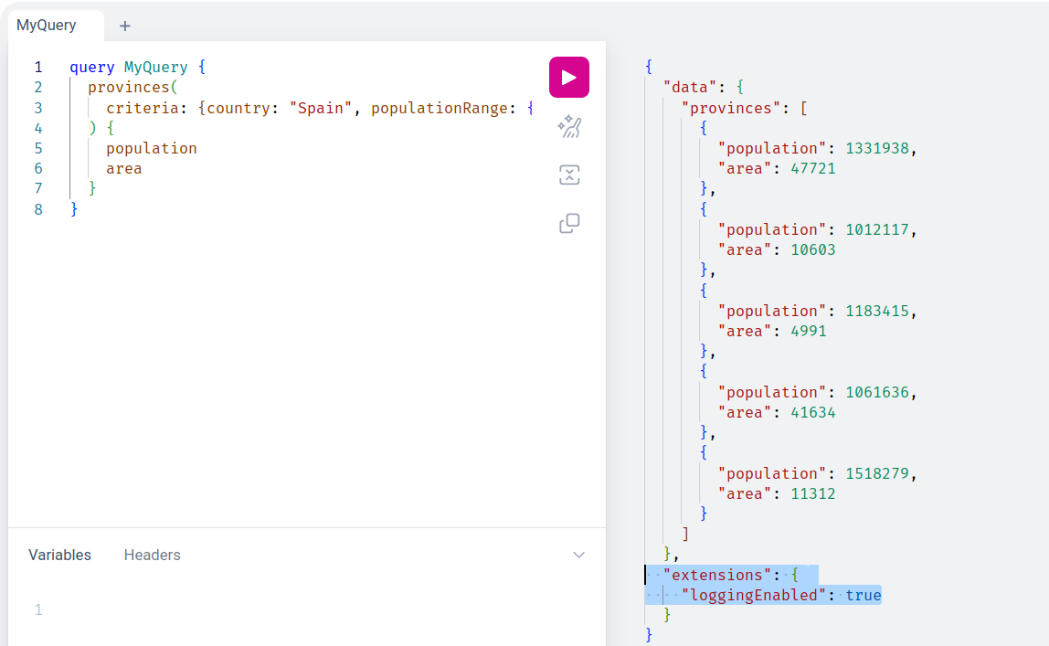

Hands-On: Implementing an Access Control Instrumentation

Add instrumentation class:
public class AccessControlInstrumentation extends SimplePerformantInstrumentation {
//imagine we have two fields that are restricted
private static final Set<String> RESTRICTED_FIELDS = Set.of("population", "area");
@Override
public @NonNull DataFetcher<?> instrumentDataFetcher(DataFetcher<?> dataFetcher, InstrumentationFieldFetchParameters parameters, InstrumentationState state) {
MergedField field = parameters.getEnvironment().getExecutionStepInfo().getField();
Set<String> permissions = parameters.getEnvironment().getGraphQlContext().get("permissions");
if (!permissions.contains("restricted") && RESTRICTED_FIELDS.contains(field.getName())) {
return (environment -> null);
}
return super.instrumentDataFetcher(dataFetcher, parameters, state);
}
}

We set permissions in the GraphQL context (still not, I mean):
…
public ExecutionResult execute(String query, Map<String, Object> variables, String operationName) {
ExecutionInput.Builder executionInputBuilder = ExecutionInput.newExecutionInput()
.graphQLContext(Map.of("permissions", Set.of()))
.query(query);
…

And now:
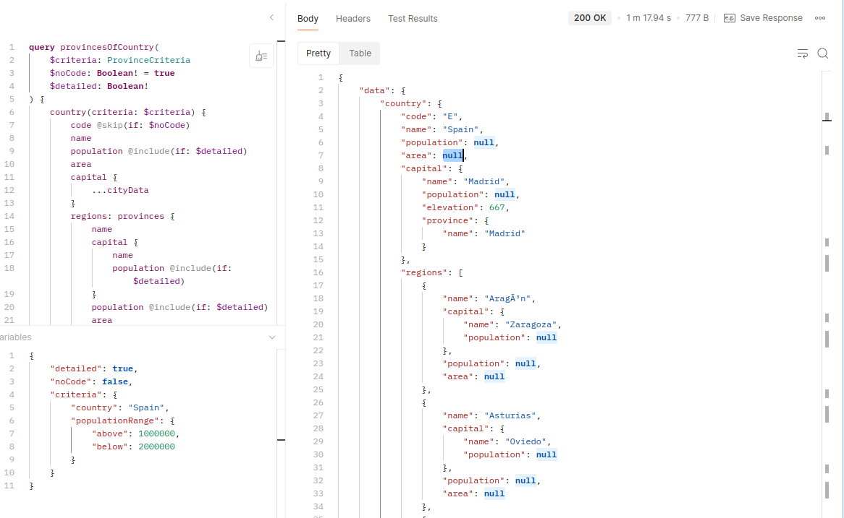

Now we give access to those restricted fields:

…
public ExecutionResult execute(String query, Map<String, Object> variables, String operationName) {
ExecutionInput.Builder executionInputBuilder = ExecutionInput.newExecutionInput()
.graphQLContext(Map.of("permissions", Set.of("restricted")))
.query(query);
…

And again we can see them:
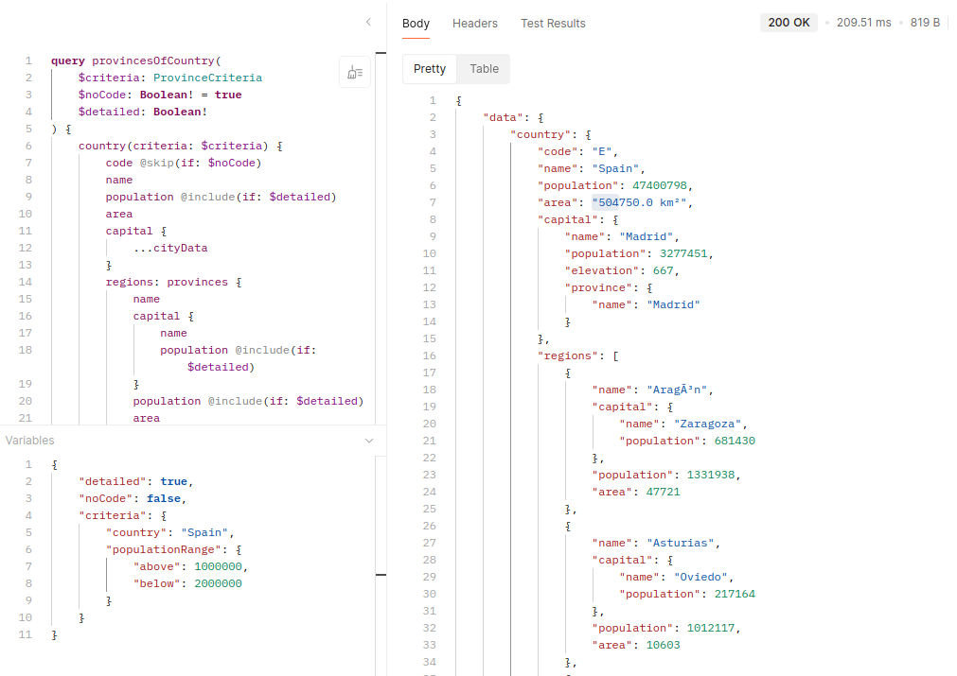

GraphQLHandler:
…
@Override
public boolean handle(Request httpRequest, Response response, Callback callback) throws Exception {
GraphQLRequest graphQLRequest = graphqlRequestFromHttp(httpRequest);
String permissionsStr = Optional.ofNullable(httpRequest.getHeaders().get("X-Permissions")).orElse("");
var permissions = Arrays.stream(permissionsStr.split(",")).map(String::trim).collect(Collectors.toSet());
ExecutionResult executionResult = graphQLRuntime.execute(graphQLRequest.query(), graphQLRequest.variables(), graphQLRequest.operationName(), permissions);
Content.Sink.write(response, true, mapper.writeValueAsString(executionResult.toSpecification()), callback);
return true;
}
…

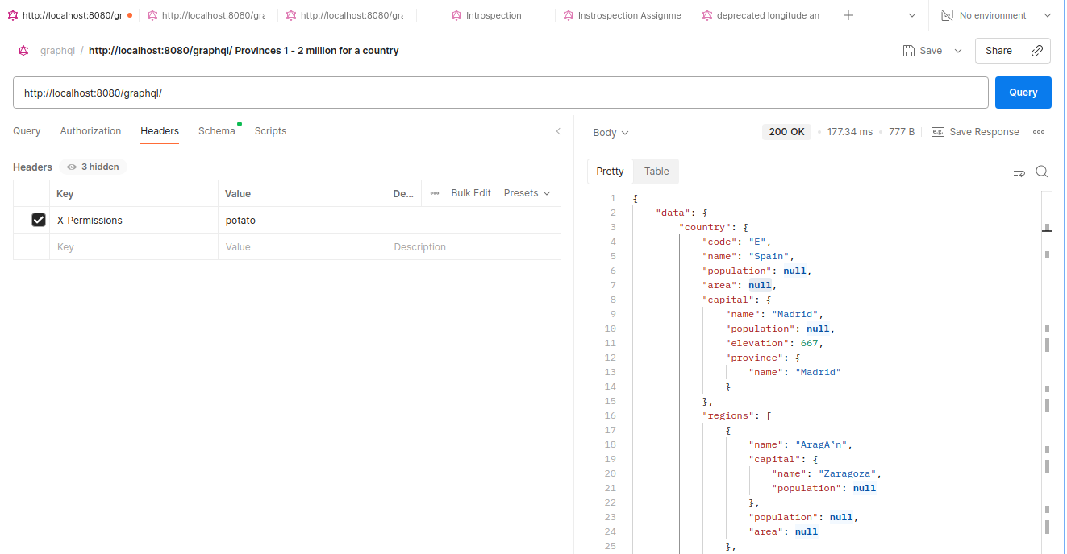

vs
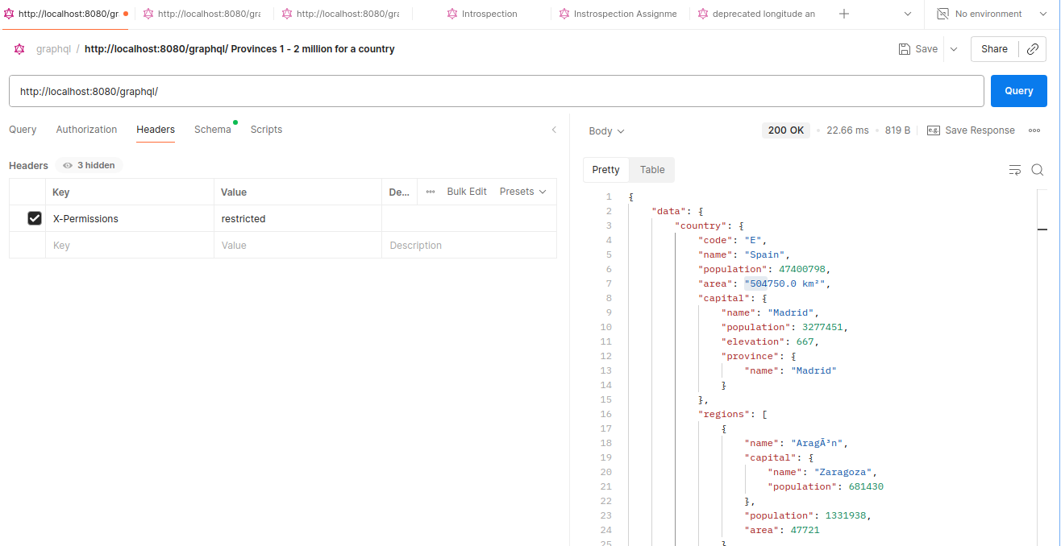

Assignment: Implementing DataFetcher Usage Tracing Using Instrumentation

Solution from instructor:
public class DataFetcherCounterInstrumentation extends SimplePerformantInstrumentation {
private static class DataFetcherUsageState implements InstrumentationState {
final Map<String, Integer> usages = new ConcurrentHashMap<>();
public void increaseUsageFor(DataFetcher<?> dataFetcher) {
synchronized (usages) {
String dataFetcherClass = dataFetcher.getClass().getSimpleName();
int prevCount = usages.getOrDefault(dataFetcherClass, 0);
usages.put(dataFetcherClass, prevCount + 1);
}
}
public Map<String, Integer> getUsages() {
return usages;
}
}
@Override
public InstrumentationState createState(InstrumentationCreateStateParameters parameters) {
return new DataFetcherUsageState();
}
@Override
public @NonNull DataFetcher<?> instrumentDataFetcher(DataFetcher<?> dataFetcher, InstrumentationFieldFetchParameters parameters, InstrumentationState state) {
if(state instanceof DataFetcherUsageState usageState) {
usageState.increaseUsageFor(dataFetcher);
return dataFetcher;
} else {
throw new RuntimeException("GraphQL didn't give us back a proper state");
}
}
@Override
public @NonNull CompletableFuture<ExecutionResult> instrumentExecutionResult(ExecutionResult executionResult, InstrumentationExecutionParameters parameters, InstrumentationState state) {
if(state instanceof DataFetcherUsageState usageState) {
return CompletableFuture.completedFuture(executionResult.transform(builder -> builder.addExtension(
"dataFetcherUsage", usageState.getUsages()
)));
} else {
throw new RuntimeException("GraphQL didn't give us back a proper state");
}
}
}

...
{
"name": "Zürich",
"population": 1553423,
"capital": {
"name": " Zürich",
"population": 421878,
"province": {
"name": "Zürich"
}
}
}
]
},
"extensions": {
"dataFetcherUsage": {
"PropertyDataFetcher": 130,
"DBProvinceFromCapitalDataFetcher": 26,
"DBProvincesOfCountryDataFetcher": 1,
"DBCityDataFetcher": 26
}
}
}

Section 13 – Execution

Execution Phases and Asynchronicity

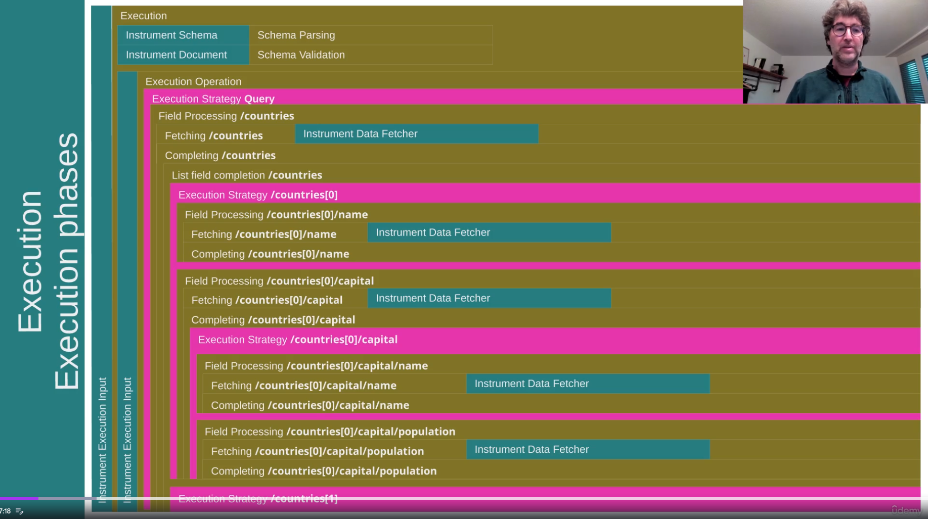
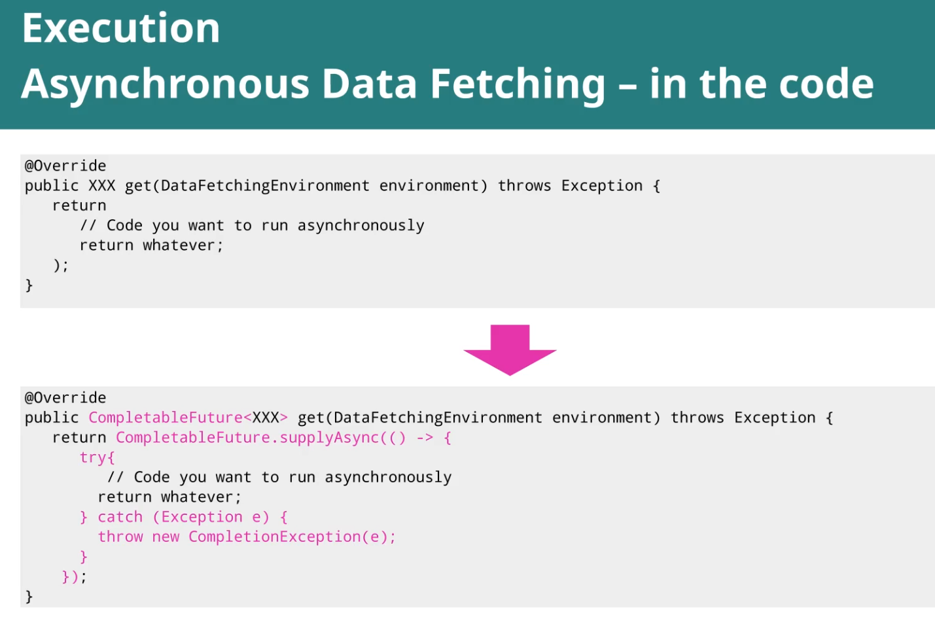

Hands-On: Making our Data Fetching Asynchronous

Make data fetchers asynchronous:
//Wire Data Fetchers
.type("Query", builder -> builder.dataFetcher("countries", async(new DBCountriesDataFetcher(dbConnection))))
.type("Query", builder -> builder.dataFetcher("country", async(new DBOneCountryDataFetcher(dbConnection))))
.type("Query", builder -> builder.dataFetcher("provinces", async(new DBProvincesOfCountryDataFetcher(dbConnection))))
.type("Query", builder -> builder.dataFetcher("places", async(new DBPlacesDataFetcher(dbConnection))))
.type("Country", builder -> builder.dataFetcher("capital", async(new DBCityDataFetcher<>(dbConnection,Country::capital))))
.type("Country", builder -> builder.dataFetcher("provinces", async(new DBProvincesOfCountryDataFetcher(dbConnection))))
.type("Province", builder -> builder.dataFetcher("capital", async(new DBCityDataFetcher<>(dbConnection,Province::capital))))
.type("City", builder -> builder
.dataFetcher("province", async(new DBProvinceFromCapitalDataFetcher(dbConnection)))

async builds an AsyncDataFetcher around the original data fetchers:
@PublicApi
public class AsyncDataFetcher<T> implements DataFetcher<CompletableFuture<T>> {
private final DataFetcher<T> wrappedDataFetcher;
private final Executor executor;
public static <T> AsyncDataFetcher<T> async(DataFetcher<T> wrappedDataFetcher) {
return new AsyncDataFetcher<T>(wrappedDataFetcher);
}

We can control how many threads will run our async data fetchers like this:

private RuntimeWiring buildRuntimeWiring(Connection dbConnection) {
try (ExecutorService executorService = Executors.newFixedThreadPool(8)) {
…

//Wire Data Fetchers
.type("Query", builder -> builder.dataFetcher("countries", async(new DBCountriesDataFetcher(dbConnection), executorService)))
.type("Query", builder -> builder.dataFetcher("country", async(new DBOneCountryDataFetcher(dbConnection), executorService)))
…

And of course we can build our own async data fetcher:

public class AsyncDBCountriesDataFetcher implements DataFetcher<CompletableFuture<List<Country>>> {
private final Connection dbConnection;
public AsyncDBCountriesDataFetcher(Connection dbConnection) {
this.dbConnection = dbConnection;
}
@Override
public CompletableFuture<List<Country>> get(DataFetchingEnvironment environment) throws Exception {
Map<String, Object> criteria = environment.getArgument("criteria");
return CompletableFuture.supplyAsync( () -> {
try (var statement = queryWithCriteria(criteria)) {
ResultSet results = statement.executeQuery();
List<Country> mappedResults = new ArrayList<>();
while (results.next()) {
Country country = Mapping.countryOf(results);
mappedResults.add(country);
}
return mappedResults;
} catch (SQLException e) {
throw new RuntimeException(e);
}
});
}
…

Fetching Data in Batches: Batch Loading
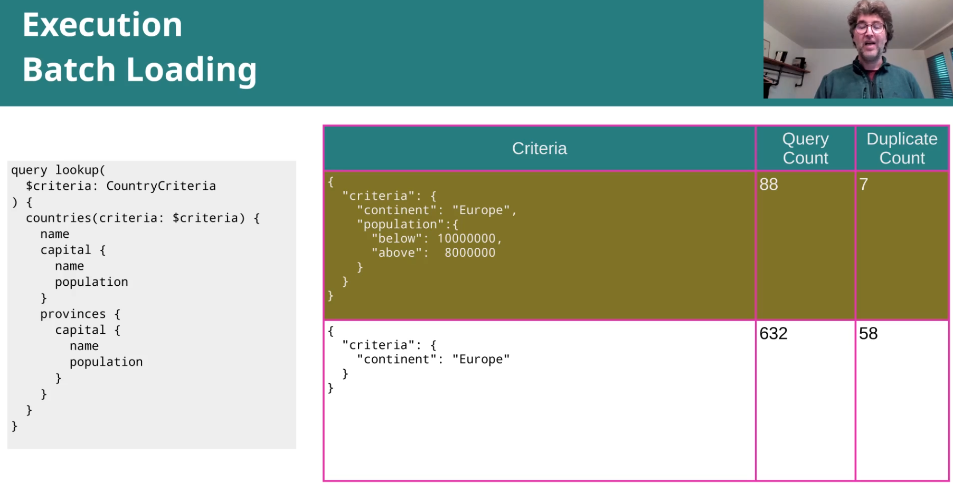
Until now we've been running queries synchronously and then asynchronously. But in all our cases, our data fetches were going to the database multiple times.
So for example, when we have a country query and we ask for the capitals, every single capital was leading to one single query to the database.

There's another mechanism in the batch loading itself that is caching. So if one piece of information has already been fetched then it's not going to refetch it. It's just going to reuse the existing data.

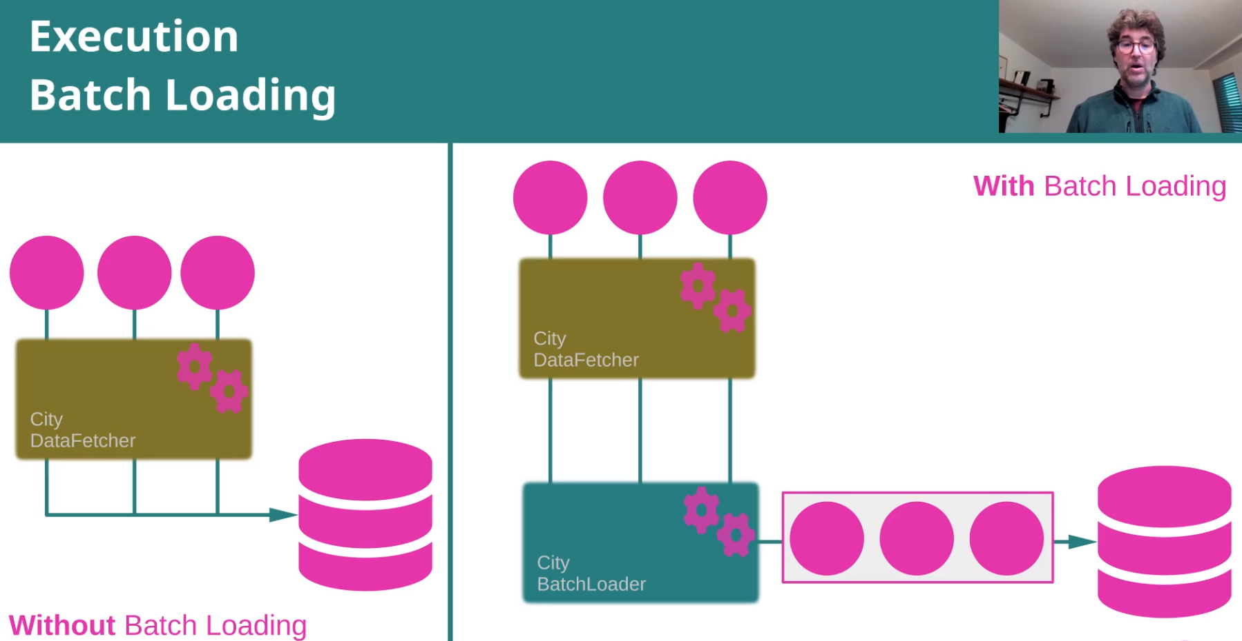

Hands-On: Using Batch Loading to Optimize the Number of Database Queries

Now we send a lot of queries to the database:
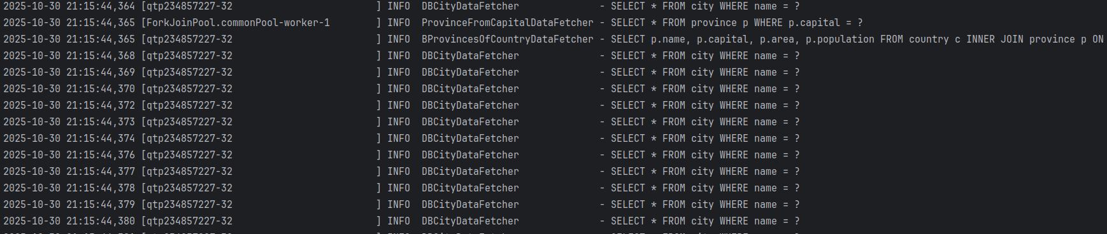
Now we don’t make so many queries to fetch the cities:
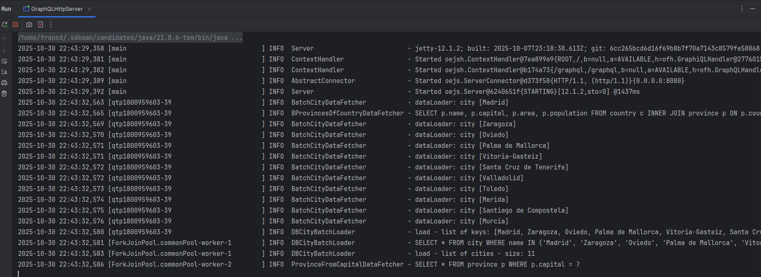
If we specify another max batch size …
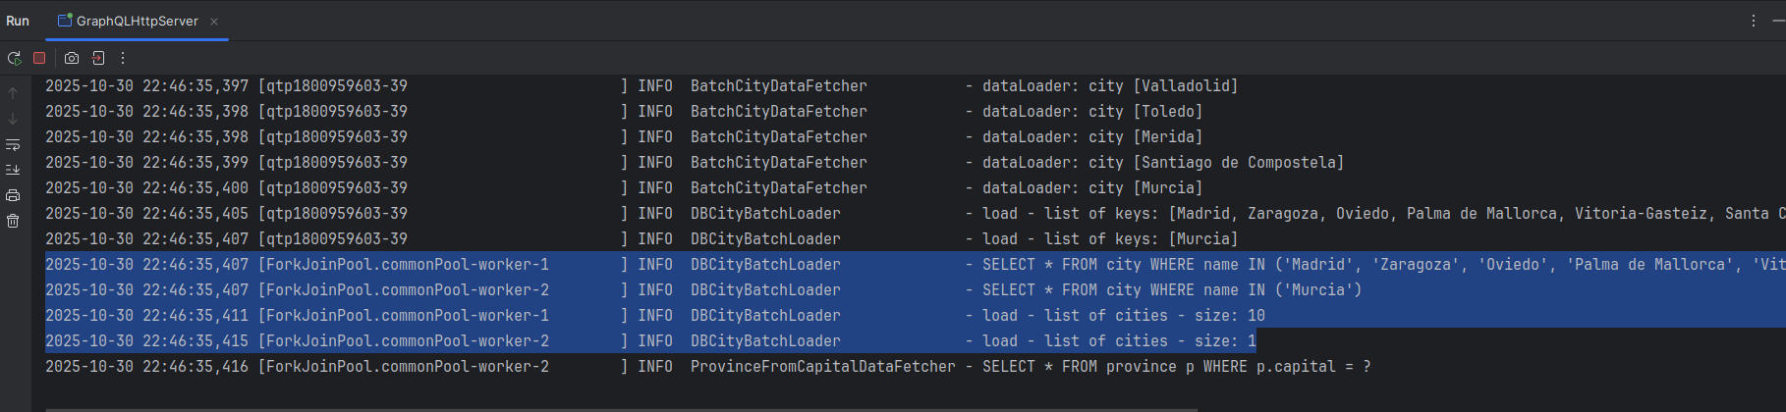

The changes in the code were:

Add a batch data fetcher:

public class BatchCityDataFetcher<T> implements DataFetcher<CompletableFuture<City>> {
private static final Logger LOGGER = LoggerFactory.getLogger(BatchCityDataFetcher.class);
private final Function<T, String> cityNameExtractor;
public BatchCityDataFetcher(Function<T, String> cityNameExtractor) {
this.cityNameExtractor = cityNameExtractor;
}
@Override
public CompletableFuture<City> get(DataFetchingEnvironment environment) throws Exception {
var capitalName = cityNameExtractor.apply(environment.getSource());
DataLoader<String, City> dataLoader = environment.getDataLoader("City");
LOGGER.info("dataLoader: city [{}]", capitalName);
return dataLoader.load(capitalName);
}
}

The data fetcher needs a data loader, that will bring the list of cities with only one :

public class DBCityBatchLoader implements BatchLoader<String, City> {
private static final Logger LOGGER = LoggerFactory.getLogger(DBCityBatchLoader.class);
private final static String CITY_SQL = """
SELECT * FROM city WHERE name IN (%s)
""";
private final Connection dbConnection;
public DBCityBatchLoader(Connection dbConnection) {
this.dbConnection = dbConnection;
}
@Override
public CompletionStage<List<City>> load(List<String> keys) {
if (keys.isEmpty()) {
LOGGER.info("load - list of keys is empty");
return CompletableFuture.completedFuture(List.of());
}
LOGGER.info("load - list of keys: {}", keys);
return CompletableFuture.supplyAsync((() -> {
try {
PreparedStatement statement = dbConnection.prepareStatement(CITY_SQL.formatted(
"'" + keys.stream().filter(Objects::nonNull)
.map(k -> k.replaceAll("'", "''"))
.collect(Collectors.joining("', '")) + "'"
));
LOGGER.info(statement.toString().replaceAll("[\\s\\n]+", " "));
ResultSet results = statement.executeQuery();
//to return results in the same order, we need to do this
Map<String, City> mappedResults = new ConcurrentHashMap<>();
while (results.next()) {
mappedResults.put(results.getString("name"), Mapping.cityOf(results));
}
LOGGER.info("load - list of cities - size: {}", mappedResults.size());
//this is what guarantees the right order: we get the order in the keys,
//so we use the keys to return the results back:
return keys.stream().map(mappedResults::get).toList();
} catch (SQLException e) {
throw new RuntimeException(e);
}
}));
}
}

And finally, wire it in GraphQLRuntime

…

private RuntimeWiring buildRuntimeWiring() {
…

//.type("Country", builder -> builder.dataFetcher("capital", new DBCityDataFetcher<>(dbConnection,Country::capital)))
.type("Country", builder -> builder.dataFetcher("capital", new BatchCityDataFetcher<>(Country::capital)))
...
//.type("Province", builder -> builder.dataFetcher("capital", new DBCityDataFetcher<>(dbConnection,Province::capital)))
.type("Province", builder -> builder.dataFetcher("capital", new BatchCityDataFetcher<>(Province::capital)))

…

}

…

public ExecutionResult execute(String query, Map<String, Object> variables, String operationName, Set<String> permissions) {
var cityDataLoader = DataLoaderFactory.newDataLoader(
new DBCityBatchLoader(dbConnection), // we can set cache options here, max batch size ...
DataLoaderOptions.newOptions().setMaxBatchSize(10).setCachingEnabled(true)
);
DataLoaderRegistry dataLoaderRegistry = new DataLoaderRegistry();
dataLoaderRegistry.register("City", cityDataLoader);
ExecutionInput.Builder executionInputBuilder = ExecutionInput.newExecutionInput()
.graphQLContext(Map.of("permissions", permissions))
.dataLoaderRegistry(dataLoaderRegistry)
.query(query);
if (variables != null) {
executionInputBuilder.variables(variables);
}
if (operationName != null) {
executionInputBuilder.operationName(operationName);
}
return graphql.execute(executionInputBuilder.build());
}

Assignment: Implement Batch Loading for Provinces

Until now:
{
"data": {
"countries": [
{
"name": "Greece",
"population": 10432481,
"area": "131940.0 km²",
"capital": {
"name": "Athina",
"population": 664046,
"elevation": 70,
"province": { ← when we ask the province of a capital city
"name": "Attikis",
"population": 3792469
}
},
...

We send many queries (one for each capital city of a country):

2025-10-31 21:23:08,872 [ForkJoinPool.commonPool-worker-1 ] INFO DBProvinceDataFetcher - SELECT * FROM province WHERE name = ?
2025-10-31 21:23:08,872 [ForkJoinPool.commonPool-worker-3 ] INFO DBProvinceDataFetcher - SELECT * FROM province WHERE name = ?
2025-10-31 21:23:08,879 [ForkJoinPool.commonPool-worker-2 ] INFO DBProvinceDataFetcher - SELECT * FROM province WHERE name = ?
2025-10-31 21:23:08,879 [ForkJoinPool.commonPool-worker-1 ] INFO DBProvinceDataFetcher - SELECT * FROM province WHERE name = ?
2025-10-31 21:23:08,881 [ForkJoinPool.commonPool-worker-3 ] INFO DBProvinceDataFetcher - SELECT * FROM province WHERE name = ?
2025-10-31 21:23:08,881 [ForkJoinPool.commonPool-worker-2 ] INFO DBProvinceDataFetcher - SELECT * FROM province WHERE name = ?
2025-10-31 21:23:08,882 [ForkJoinPool.commonPool-worker-1 ] INFO DBProvinceDataFetcher - SELECT * FROM province WHERE name = ?
2025-10-31 21:23:08,883 [ForkJoinPool.commonPool-worker-2 ] INFO DBProvinceDataFetcher - SELECT * FROM province WHERE name = ?
…

After adding batch loading for provinces:

2025-10-31 21:38:24,935 [ForkJoinPool.commonPool-worker-3 ] INFO BatchProvinceDataFetcher - dataLoader: province of city [Lisboa]
2025-10-31 21:38:24,935 [ForkJoinPool.commonPool-worker-1 ] INFO BatchProvinceDataFetcher - dataLoader: province of city [Athina]
2025-10-31 21:38:24,935 [ForkJoinPool.commonPool-worker-2 ] INFO BatchProvinceDataFetcher - dataLoader: province of city [KyÃ¯v]
2025-10-31 21:38:24,936 [ForkJoinPool.commonPool-worker-3 ] INFO BatchProvinceDataFetcher - dataLoader: province of city [Astana]
2025-10-31 21:38:24,936 [ForkJoinPool.commonPool-worker-2] INFO BatchProvinceDataFetcher - dataLoader: province of city [Bruxelles]
2025-10-31 21:38:24,936 [ForkJoinPool.commonPool-worker-1 ] INFO BatchProvinceDataFetcher - dataLoader: province of city [Beograd]
2025-10-31 21:38:24,936 [ForkJoinPool.commonPool-worker-2] INFO BatchProvinceDataFetcher - dataLoader: province of city [Amsterdam]
2025-10-31 21:38:24,936 [ForkJoinPool.commonPool-worker-1 ] INFO BatchProvinceDataFetcher - dataLoader: province of city [Madrid]
2025-10-31 21:38:24,936 [ForkJoinPool.commonPool-worker-1 ] INFO BatchProvinceDataFetcher - dataLoader: province of city [Praha]
2025-10-31 21:38:24,936 [ForkJoinPool.commonPool-worker-2 ] INFO BatchProvinceDataFetcher - dataLoader: province of city [Sofia]
2025-10-31 21:38:24,937 [ForkJoinPool.commonPool-worker-1 ] INFO BatchProvinceDataFetcher - dataLoader: province of city [Bratislava]
2025-10-31 21:38:24,937 [ForkJoinPool.commonPool-worker-2] INFO BatchProvinceDataFetcher - dataLoader: province of city [BucureÅŸti]
2025-10-31 21:38:24,937 [ForkJoinPool.commonPool-worker-1] INFO BatchProvinceDataFetcher - dataLoader: province of city [Budapest]
2025-10-31 21:38:24,937 [ForkJoinPool.commonPool-worker-2 ] INFO BatchProvinceDataFetcher - dataLoader: province of city [Copenhagen]
2025-10-31 21:38:24,937 [ForkJoinPool.commonPool-worker-1 ] INFO BatchProvinceDataFetcher - dataLoader: province of city [Bern]
2025-10-31 21:38:24,937 [ForkJoinPool.commonPool-worker-2 ] INFO BatchProvinceDataFetcher - dataLoader: province of city [Dublin]
2025-10-31 21:38:24,938 [ForkJoinPool.commonPool-worker-1 ] INFO BatchProvinceDataFetcher - dataLoader: province of city [Wien]
2025-10-31 21:38:24,938 [ForkJoinPool.commonPool-worker-2 ] INFO BatchProvinceDataFetcher - dataLoader: province of city [Helsinki]
2025-10-31 21:38:24,938 [ForkJoinPool.commonPool-worker-1 ] INFO BatchProvinceDataFetcher - dataLoader: province of city [Minsk]
2025-10-31 21:38:24,938 [ForkJoinPool.commonPool-worker-2 ] INFO BatchProvinceDataFetcher - dataLoader: province of city [Oslo]
2025-10-31 21:38:24,939 [ForkJoinPool.commonPool-worker-1] INFO BatchProvinceDataFetcher - dataLoader: province of city [Warszawa]
2025-10-31 21:38:24,939 [ForkJoinPool.commonPool-worker-2] INFO BatchProvinceDataFetcher - dataLoader: province of city [Stockholm]
2025-10-31 21:38:24,939 [ForkJoinPool.commonPool-worker-2 ] INFO DBProvinceBatchLoader - load - list of keys: [Lisboa, Attikis, KyÃ¯v, Astana, Bruxelles, Serbia, Noord-Holland, Madrid, Praha, Bulgaria]
2025-10-31 21:38:24,939 [ForkJoinPool.commonPool-worker-2 ] INFO DBProvinceBatchLoader - load - list of keys: [BratislavskÃ½, BucureÅŸti, Budapest, Hovedstaden, Bern, Leinster, Wien, Uusimaa, Minsk City, Oslo]
2025-10-31 21:38:24,940 [ForkJoinPool.commonPool-worker-2 ] INFO DBProvinceBatchLoader - load - list of keys: [Mazowieckie, Stockholm]
2025-10-31 21:38:24,940 [ForkJoinPool.commonPool-worker-1 ] INFO DBProvinceBatchLoader - SELECT p.name, p.capital, p.area, p.population FROM province p WHERE p.name IN ('Lisboa', 'Attikis', 'KyÃ¯v', 'Astana', 'Bruxelles', 'Serbia', 'Noord-Holland', 'Madrid', 'Praha', 'Bulgaria')
2025-10-31 21:38:24,940 [ForkJoinPool.commonPool-worker-4 ] INFO DBProvinceBatchLoader - SELECT p.name, p.capital, p.area, p.population FROM province p WHERE p.name IN ('Mazowieckie', 'Stockholm')
2025-10-31 21:38:24,942 [ForkJoinPool.commonPool-worker-1 ] INFO DBProvinceBatchLoader - load - list of provinces - size: 10
2025-10-31 21:38:24,942 [ForkJoinPool.commonPool-worker-3 ] INFO DBProvinceBatchLoader - SELECT p.name, p.capital, p.area, p.population FROM province p WHERE p.name IN ('BratislavskÃ½', 'BucureÅŸti', 'Budapest', 'Hovedstaden', 'Bern', 'Leinster', 'Wien', 'Uusimaa', 'Minsk City', 'Oslo')
2025-10-31 21:38:24,942 [ForkJoinPool.commonPool-worker-4 ] INFO DBProvinceBatchLoader - load - list of provinces - size: 2
2025-10-31 21:38:24,943 [ForkJoinPool.commonPool-worker-3 ] INFO DBProvinceBatchLoader - load - list of provinces - size: 10

